FBG-HDE TABLE OF COLORED PART 2013

TABLE OF COLORED PART（New Blade 550i SE 4X4）
ITEMNO. | CODE | A | B | C | D | E
ITEMNO. | Basic Color | Black | White | Silver Gray | Red | Orange
ITEMNO. | Description | BL | WH | SG | RD | OR
B01 | Cover, Handle Bar, Front.,  With emblem | 513103BLF9 | 513103WHF9 | 513103SGF9 | 513103RDF9 | 513103ORF9
B01 | Cover, Handle Bar, Front | 513103BL | 513103WH | 513103SG | 513103RD | 513103OR
B01 | Emblem | 517524 | 517524 | 517524 | 517524 | 517524
B21 | Front body cover, With emblem | 512465EBLFA | 512465EWHFB | 512465ESGFC | 512465ERDFD | 512465EORFL
B21 | Front body cover | 512465EBL | 512465EWH | 512465ESG | 512465ERD | 512465EOR
B21 | Emblem | 517263BL | 517263WH | 517263SG | 517263RDA | 517263OR
B21 | Emblem | 517264BL | 517264WH | 517264SG | 517264RDA | 517264OR
B21 | Glove compartment cover, LH | 512421BL | 512421WH | 512421SG | 512421RD | 512421OR
B21 | Glove compartment cover, RH | 512422BL | 512422WH | 512422SG | 512422RD | 512422OR
B21 | Carrier cover | 512425BL | 512425WH | 512425SG | 512425RD | 512425OR
B21 | Reservoir cover | 512424BL | 512424WH | 512424SG | 512424RD | 512424OR
B22 | Side cover, LH, With emblem | 512522BLLCE | 512522WHLCF | 512522SGLCG | 512522RDLCH | 512522ORLCJ
B22 | Side cover, LH | 512522BL | 512522WH | 512522SG | 512522RD | 512522OR
B22 | Emblem | 517267BL | 517267WH | 517267SG | 517267RDA | 517267OR
B22 | Emblem | 517268BL | 517268WH | 517268SG | 517268RDA | 517268OR
B22 | Emblem | 517269BL | 517269WH | 517269SG | 517269RDA | 517269OR
B22 | Emblem | 517270BL | 517270WH | 517270SG | 517270RDA | 517270OR
B22 | Emblem | 517522BL | 517522WH | 517522SG | 517522RDA | 517522OR
B22 | Side cover, RH, With emblem | 512523BBLRCE-1 | 512523BWHRCF-1 | 512523BSGRCG-1 | 512523BRDRCH-1 | 512523BORRCJ-1
B22 | Side cover, RH | 512523BBL | 512523BWH | 512523BSG | 512523BRD | 512523BOR
B22 | Emblem | 517272BL | 517272WH | 517272SG | 517272RDA | 517272OR
B22 | Emblem | 517273BL | 517273WH | 517273SG | 517273RDA | 517273OR
B22 | Emblem | 517274BL | 517274WH | 517274SG | 517274RDA | 517274OR
B22 | Emblem | 517275BL | 517275WH | 517275SG | 517275RDA | 517275OR
B22 | Emblem | 517523BL | 517523WH | 517523SG | 517523RDA | 517523OR
B22 | Fuel tank cover, upper | 512505BL | 512505WH | 512505SG | 512505RD | 512505OR
B23 | Rear body cover, With emblem | 514459GBLRF | 514459GWHRG | 514459GSGRH | 514459GRDRJ | 514459GORRA2
B23 | Rear body cover | 514459GBL | 514459GWH | 514459GSG | 514459GRD | 514459GOR
B23 | Emblem | 517277BL | 517277WH | 517277SG | 517277RDA | 517277OR
B23 | Emblem | 517278BL | 517278WH | 517278SG | 517278RDA | 517278OR
B23 | Carrier cover | 512425BL | 512425WH | 512425SG | 512425RD | 512425OR

I
FBG-HDE TABLE OF COLORED PART 2013

TABLE OF COLORED PART（New Blade 550 SE Fi 4X4 For EPS）
ITEMNO. | CODE | A
ITEMNO. | Basic Color | Bronze Brown
ITEMNO. | Description | BB
B01 | Cover, Handle Bar, Front., With emblem | 513103BBF8
B01 | Cover, Handle Bar, Front | 513103BB
B01 | Emblem | 517302
B21 | Front body cover, With emblem | 512465EBBFE
B21 | Front body cover | 512465EBB
B21 | Emblem | 517301
B21 | Glove compartment cover, LH | 512421BB
B21 | Glove compartment cover, RH | 512422BB
B21 | Carrier cover | 512425BB
B21 | Reservoir cover | 512424BB
B22 | Side cover, LH, With emblem | 512522BBLF5
B22 | Side cover, LH | 512522BB
B22 | Emblem | 517303
B22 | Emblem | 517304
B22 | Emblem | 517305
B22 | Side cover, RH, With emblem | 512523BBBRF5
B22 | Side cover, RH | 512523BBB
B22 | Emblem | 517306
B22 | Emblem | 517307
B22 | Emblem | 517308
B22 | Fuel tank cover, upper | 512505BB
B22 | Rear body cover | 514459GBB
B22 | Carrier cover | 512425BB

I
FBG-HDE TABLE OF COLORED PART 2012

TABLE OF COLORED PART（New Blade 550i SE 4X4）
ITEM | CODE | A | B | C | D | E
NO. | Basic Color | Black | White | Orange | Red | Silver Gray
 | Description | BL | WH | OR | RD | SG
B01 | Cover, Handle Bar, Front | 513103BL | 513103WH | 513103OR | 513103RD | 513103SG
 | Front body cover, With emblem | 512465EBLF1 | 512465EWHF2 | 512465EORF3 | 512465ERDF4 | 512465ESGF5
 | Front body cover | 512465EBL | 512465EWH | 512465EOR | 512465ERD | 512465ESG
 | Emblem | 517230BL | 517230WH | 517230OR | 517230RDA | 517230SG
B21 | Emblem | 517231BL | 517231WH | 517231OR | 517231RDA | 517231SG
 | Glove compartment cover, LH | 512421BL | 512421WH | 512421OR | 512421RD | 512421SG
 | Glove compartment cover, RH | 512422BL | 512422WH | 512422OR | 512422RD | 512422SG
 | Carrier cover | 512425BL | 512425WH | 512425OR | 512425RD | 512425SG
 | Reservoir cover | 512424BL | 512424WH | 512424OR | 512424RD | 512424SG
 | Side cover, LH, With emblem | 512540CALA8 | 512540CALAA | 512540CALAC | 512540CALA9 | 512540CALAB
 | Side cover, LH | 512540CA | 512540CA | 512540CA | 512540CA | 512540CA
 | Emblem | 516689BL | 516689WH | 516689OR | 516689RDA | 516689SG
 | Emblem | 516690BL | 516690WH | 516690OR | 516690RDA | 516690SG
 | Emblem | 516691BL | 516691WH | 516691OR | 516691RDA | 516691SG
 | Emblem | 516692BL | 516692WH | 516692OR | 516692RDA | 516692SG
 | Emblem | 517065BL | 517065WH | 517065OR | 517065RDA | 517065SG
B22 | Side cover, RH, With emblem | 512541CBRA8 | 512541CBRAA | 512541CBRAC | 512541CBRA9 | 512541CBRAB
 | Side cover, RH | 512541CB | 512541CB | 512541CB | 512541CB | 512541CB
 | Emblem | 516694BL | 516694WH | 516694OR | 516694RDA | 516694SG
 | Emblem | 516695BL | 516695WH | 516695OR | 516695RDA | 516695SG
 | Emblem | 516696BL | 516696WH | 516696OR | 516696RDA | 516696SG
 | Emblem | 516697BL | 516697WH | 516697OR | 516697RDA | 516697SG
 | Emblem | 517066BL | 517066WH | 517066OR | 517066RDA | 517066SG
 | Fuel tank cover, upper | 512539C | 512539C | 512539C | 512539C | 512539C
 | Rear body cover, With emblem | 514459GBLR9 | 514459GWHR5 | 514459GORR6 | 514459GRDRC | 514459GSGR4
 | Rear body cover | 514459GBL | 514459GWH | 514459GOR | 514459GRD | 514459GSG
B23 | Emblem | 516699BL | 516699WH | 516699OR | 516699RDA | 516699SG
 | Emblem | 516700BL | 516700WH | 516700OR | 516700RDA | 516700SG
 | Carrier cover | 512425BL | 512425WH | 512425OR | 512425RD | 512425SG

Ⅰ
FBG-HDE TABLE OF LABEL 2013
Label | Drawing | Description
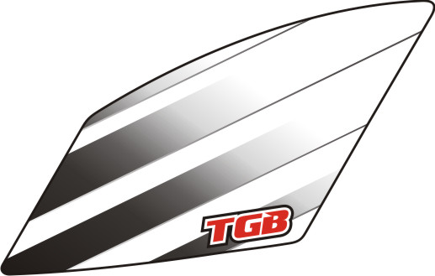 | 517263BL  517263WH  517263SG  517263RDA  517263OR | Emblem, Front body cover.
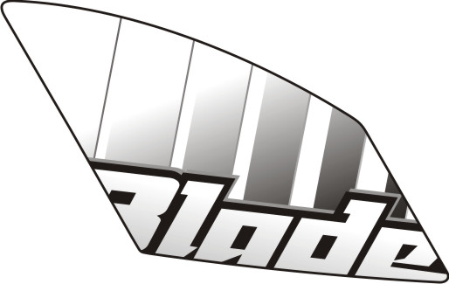 | 517264BL  517264WH  517264SG  517264RDA  517264OR | Emblem, Front body cover.
 | 517279 | Emblem, Cover, Handle Bar, Front.
 | 517267BL  517267WH  517267SG  517267RDA  517267OR | Emblem, Side cover, LH.
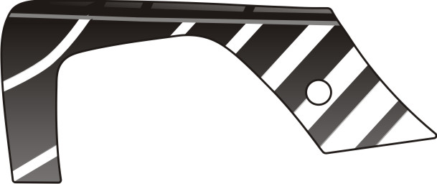 | 517268BL  517268WH  517268SG  517268RDA  517268OR | Emblem, Side cover, LH.
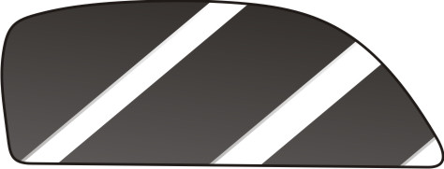 | 517269BL  517269WH  517269SG  517269RDA  517269OR | Emblem, Side cover, LH.
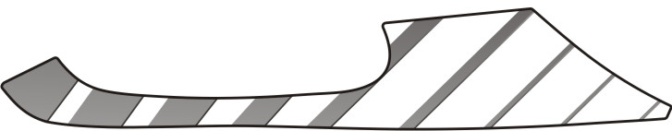 | 517270BL  517270WH  517270SG  517270RDA  517270OR | Emblem, Side cover, LH.
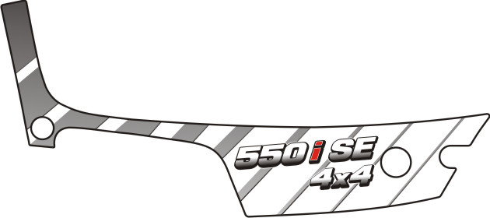 | 517522BL  517522WH  517522SG  517522RDA  517522OR | Emblem, Side cover, LH.
I
FBG-HDE TABLE OF LABEL 2013
Label | Drawing | Description
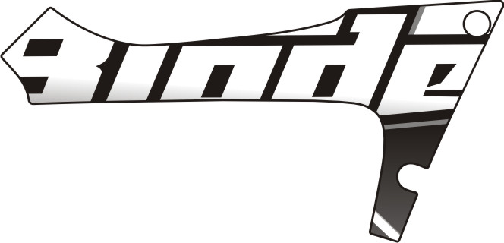 | 517272BL  517272WH  517272SG  517272RDA  517272OR | Emblem, Side cover, RH.
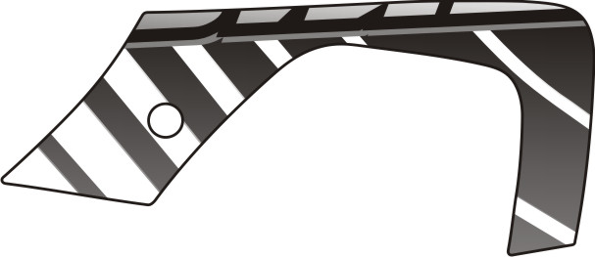 | 517273BL  517273WH  517273SG  517273RDA  517273OR | Emblem, Side cover, RH.
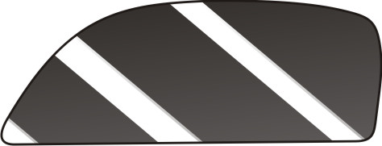 | 517274BL  517274WH  517274SG  517274RDA  517274OR | Emblem, Side cover, RH.
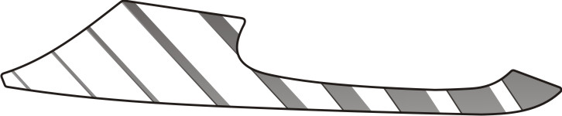 | 517275BL  517275WH  517275SG  517275RDA  517275OR | Emblem, Side cover, RH.
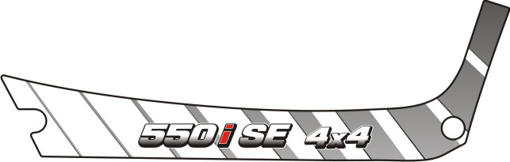 | 517523BL  517523WH  517523SG  517523RDA  517523OR | Emblem, Side cover, RH.
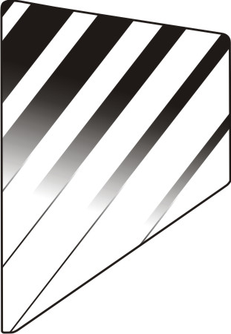 | 517277BL  517277WH  517277SG  517277RDA  517277OR | Emblem, Rear cover, LH.
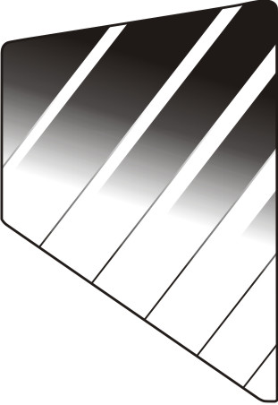 | 517278BL  517278WH  517278SG  517278RDA  517278OR | Emblem, Rear cover, RH.

II
FBG-HDE TABLE OF LABEL 2013
Label | Drawing | Description
 | 517301 | Emblem, Front body cover., RH.
 | 517302 | Emblem, Cover, Handle Bar, Front.
 | 517303 | Emblem, Side cover, LH.
 | 517304 | Emblem, Side cover, LH.
 | 517305 | Emblem, Side cover, LH.
 | 517306 | Emblem, Side cover, RH.
 | 517307 | Emblem, Side cover, RH.
 | 517308 | Emblem, Side cover, RH.

I
FBG-HDE TABLE OF LABEL 2012
Label | Drawing | Description
 | 517230BL  517230RDA  517230WH  517230SG  517230OR | Emblem, Front body cover., LH.
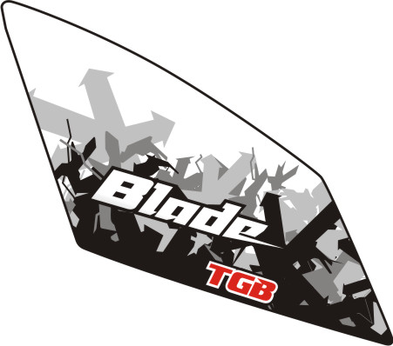 | 517231BL  517231RDA  517231WH  517231SG  517231OR | Emblem, Front body cover., RH.
 | 516689BL  516689RDA  516689WH  516689SG  516689OR | Emblem, Side cover, LH.
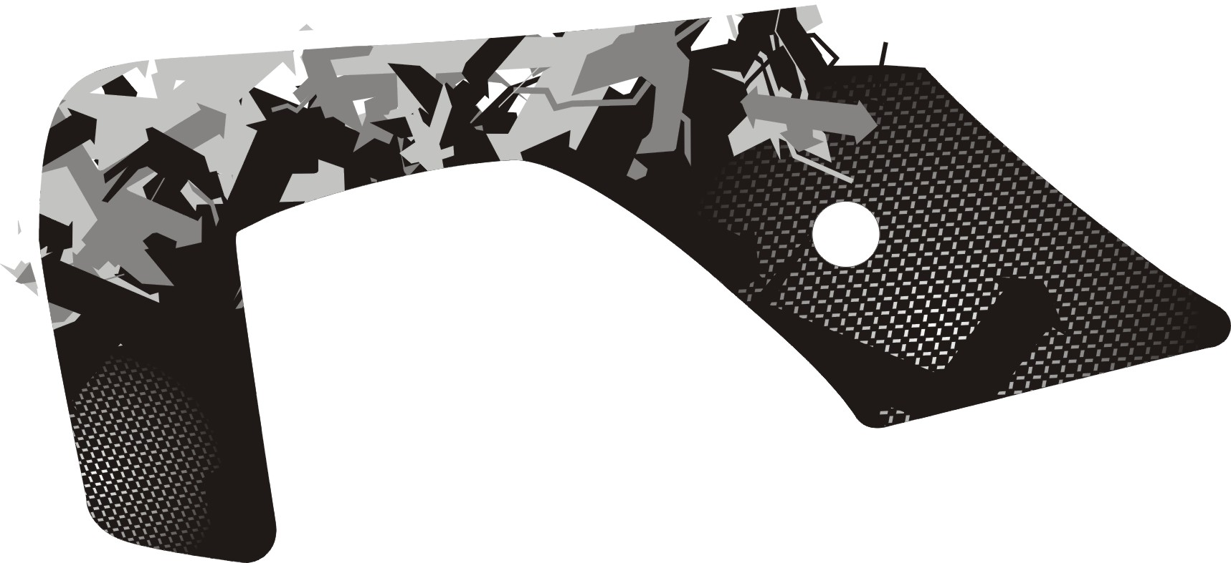 | 516690BL  516690RDA  516690WH  516690SG  516690OR | Emblem, Side cover, LH.
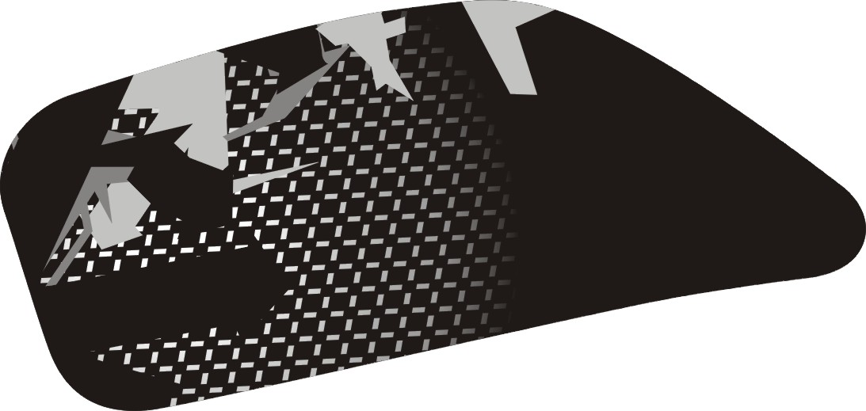 | 516691BL  516691RDA  516691WH  516691SG  516691OR | Emblem, Side cover, LH.
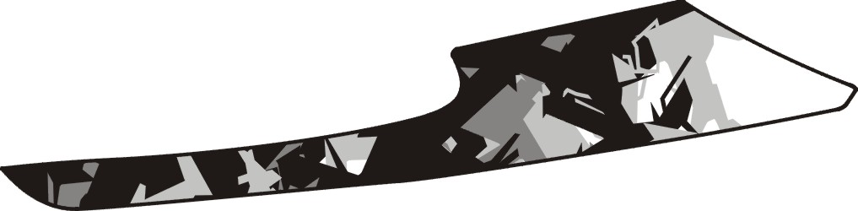 | 516692BL  516692RDA  516692WH  516692SG  516692OR | Emblem, Side cover, LH.
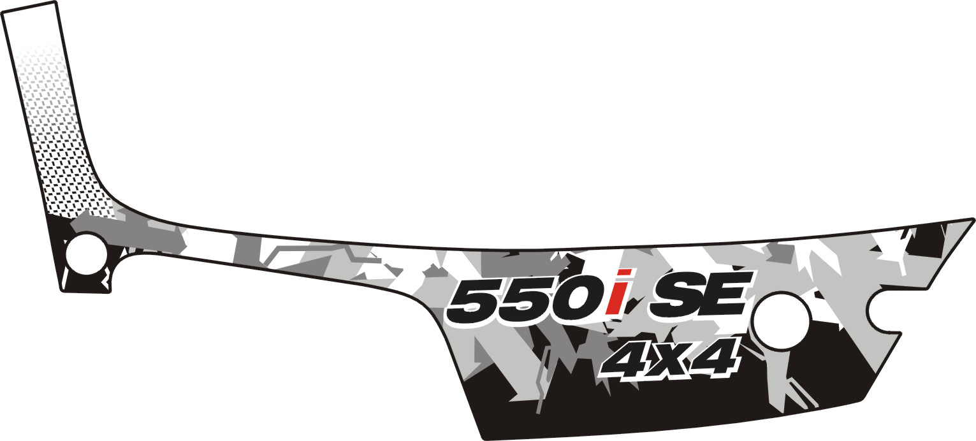 | 517065BL  517065RDA  517065WH  517065SG  517065OR | Emblem, Side cover, LH.

I
FBG-HDE TABLE OF LABEL 2012
Label | Drawing | Description
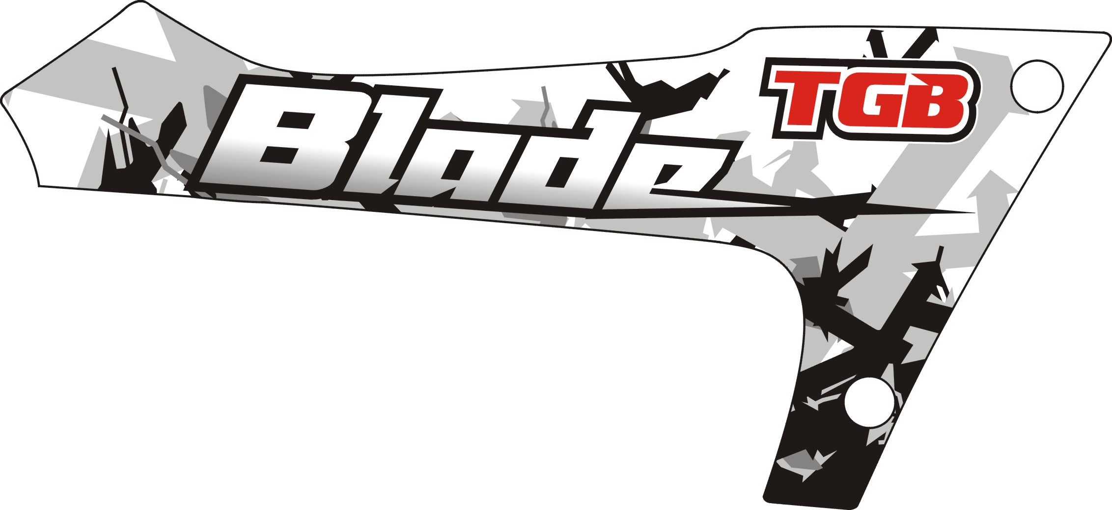 | 516694BL  516694RDA  516694WH  516694SG  516694OR | Emblem, Side cover, RH.
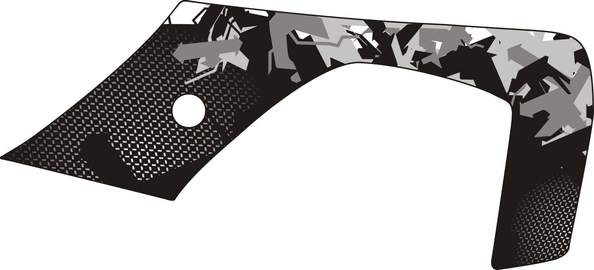 | 516695BL  516695RDA  516695WH  516695SG  516695OR | Emblem, Side cover, RH.
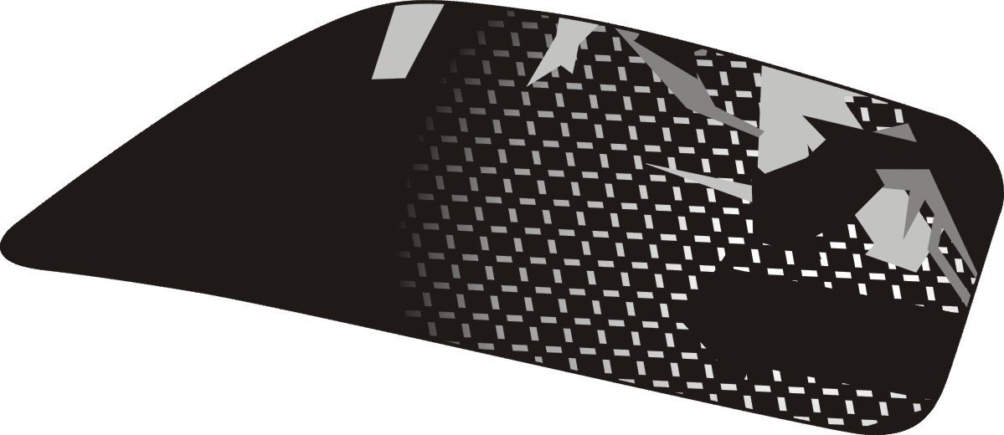 | 516696BL  516696RDA  516696WH  516696SG  516696OR | Emblem, Side cover, RH.
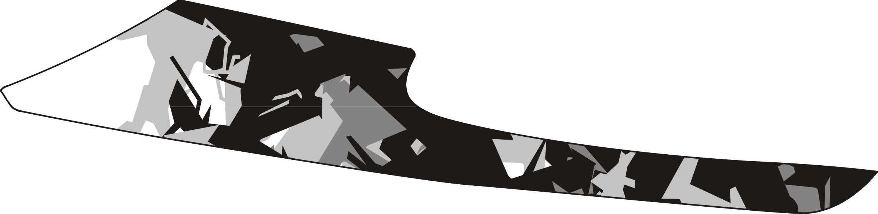 | 516697BL  516697RDA  516697WH  516697SG  516697OR | Emblem, Side cover, RH.
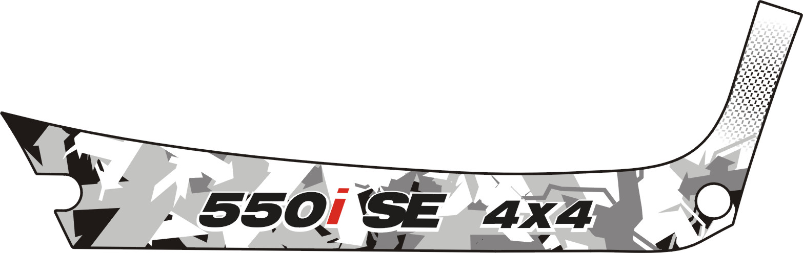 | 517066BL  517066RDA  517066WH  517066SG  517066OR | Emblem, Side cover, RH.
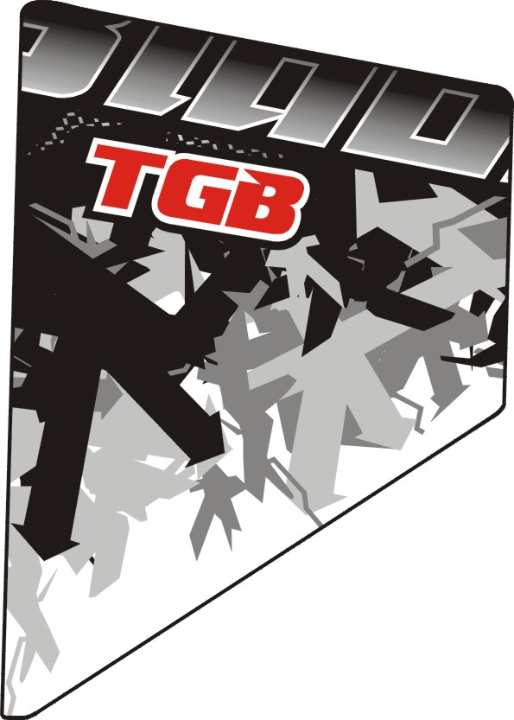 | 516699BL  516699RDA  516699WH  516699SG  516699OR | Emblem,Rear cover, LH.
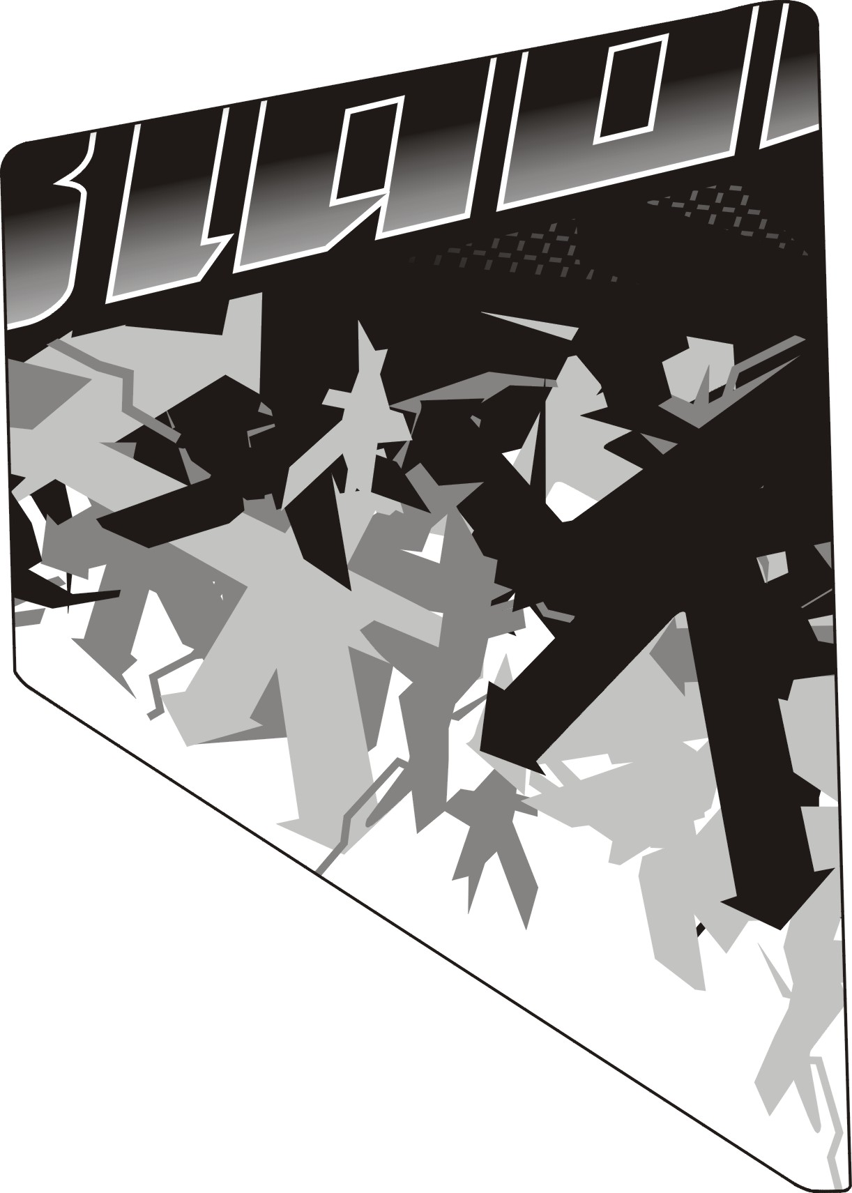 | 516700BL  516700RDA  516700WH  516700SG  516700OR | Emblem,Rear cover, RH.

II

