VSG TABLE OF COLORED PART 2009
FOR CZECHOSLOVAKIA

TABLE OF COLORED PART(TARGET 525 4×4)
ITEM | CODE | A | B | C | D
NO. | Basic Color | Red | White | Orange | Black
 | Description | RD | WH | OR | BL
B05 | SHOCK ABSORBER, REAR | 511649RD | 511649RD | 511649RD | 511649YE
B11 | SHOCK ABSORBER ASSY., FRONT | 513345RD | 513345RD | 513345RD | 513345YE
 | FRONT BODY COVER, With Emblem | 512463HRDF1 | 512463HWHF1 | 512463HORF1 | 512463HBLF1
 | FRONT BODY COVER | 512463HRD | 512463HWH | 512463HOR | 512463HBL
 | Emblem | 515654 | 515654 | 515654 | 515654
 | Emblem | 516642 | 516642 | 516642 | 516642
 | Emblem | 515656 | 515656 | 515656 | 515656
 | Emblem | 515657 | 515657 | 515657 | 515657
B20 | Emblem | 515659 | 515659 | 515659 | 515659
 | Emblem | 515660 | 515660 | 515660 | 515660
 | Emblem | 515658 | 515658 | 515658 | 515658
 | ORNAMENTAL, FRONT COVER, With Emblem | 512445CF1 | 512445CF1 | 512445CF1 | 512445CF1
 | ORNAMENTAL, FRONT COVER | 512445C | 512445C | 512445C | 512445C
 | Emblem | 516644 | 516644 | 516644 | 516644
 | COVER SIDE, LH., With Emblem | 512529CL1 | 512529CL1 | 512529CL1 | 512529CL1
 | COVER SIDE, LH. | 512529C | 512529C | 512529C | 512529C
B21 | Emblem | 517207 | 517207 | 517207 | 517207
 | COVER SIDE, RH., With Emblem | 512530CAR1 | 512530CAR1 | 512530CAR1 | 512530CAR1
 | COVER SIDE, RH. | 512530CA | 512530CA | 512530CA | 512530CA
 | Emblem | 517208 | 517208 | 517208 | 517208
 | REAR BODY COVER COMP., With Emblem | 514426ARDR1 | 514426AWHR1 | 514426AORR1 | 514426ABLR1
 | REAR BODY COVER COMP. | 514426ARD | 514426AWH | 514426AOR | 514426ABL
 | Emblem | 515667 | 515667 | 515667 | 515667
B22 | Emblem | 515668 | 515668 | 515668 | 515668
 | Emblem | 515681 | 515681 | 515681 | 515681
 | Emblem | 515682 | 515682 | 515682 | 515682
 | ORNAMENTAL, CARRIER TAIL | 515098RD | 515098WH | 515098OR | 515098BL

Ⅰ
VSG TABLE OF LABEL
Label | Drawing | Description
 | 515654 | FRONT BODY COVER
 | 516642 | FRONT BODY COVER
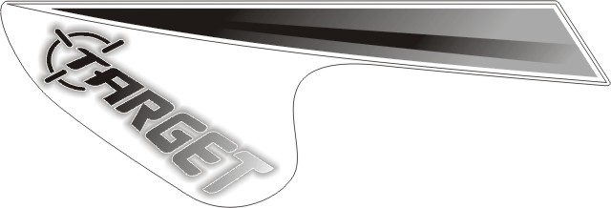 | 515656 | FRONT BODY COVER
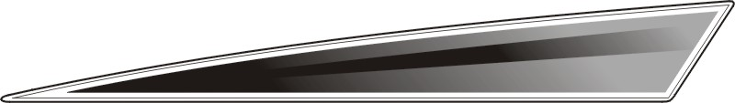 | 515657 | FRONT BODY COVER
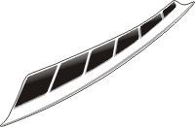 | 515659 | FRONT BODY COVER
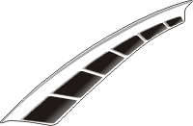 | 515660 | FRONT BODY COVER
 | 515658 | FRONT BODY COVER
 | 516644 | ORNAMENTAL, FRONT COVER
 | 517207 | COVER SIDE, LH.
 | 517208 | COVER SIDE, RH.

I
VSG TABLE OF LABEL
Label | Drawing | Description
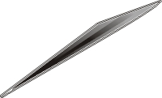 | 515681 | REAR BODY COVER COMP.
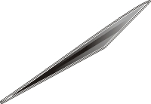 | 515682 | REAR BODY COVER COMP.
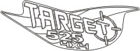 | 515667 | REAR BODY COVER COMP.
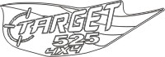 | 515668 | REAR BODY COVER COMP.

II

