FCC TABLE OF COLORED PART

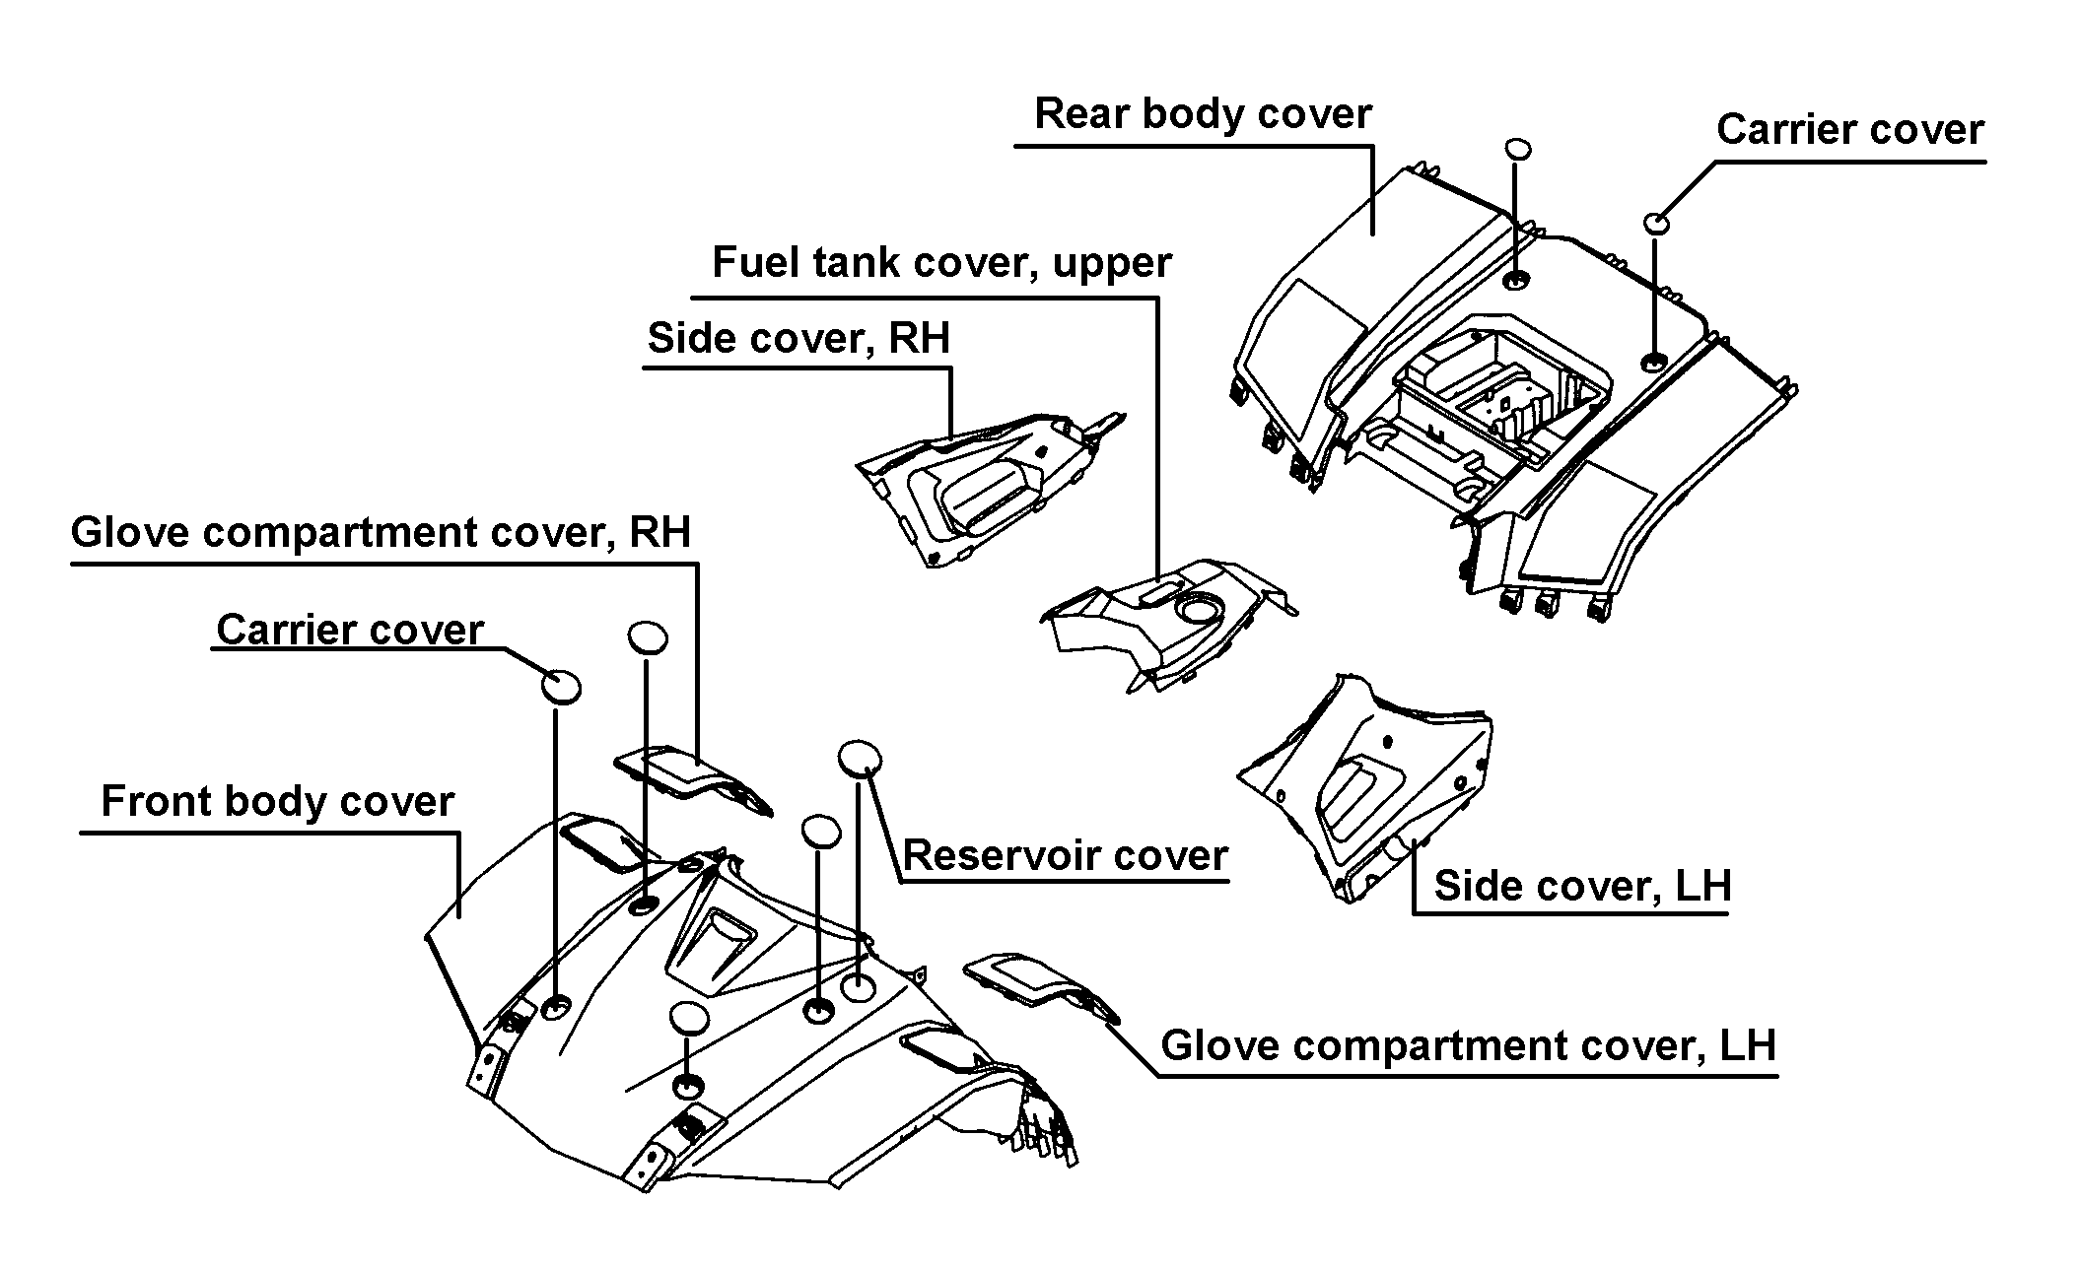

TABLE OF COLORED PART (325)
ITEM | CODE | A | B
NO. | Basic Color | Black | Red
 | Description | BL | RD
 | Front body cover(←002495) | 512465HBL | 512465HRD
 | Front body cover(002496→) | 512465BL | 512465RD
B21 | Glove compartment cover, LH | 512421BL | 512421RD
 | Glove compartment cover, RH | 512422BL | 512422RD
 | Carrier cover | 512425BL | 512425RD
 | Reservoir cover | 512424BL | 512424RD
 | Side cover, LH, With emblem | 512522BLLE | 512522RDLF
 | Side cover, LH | 512522BL | 512522RD
 | “325” Label | 514677FR | 514677BL
 | “BLAND” Label | 513675FR | 513675BL
 | Label, Side cover,LH. | 513669FR | 513669BL
 | Label, Side cover,LH. | 513670FR | 513670BL
 | Label, Side cover,LH. | 514651FR | 514651BL
B22 | Side cover, RH, With emblem | 512523BLRE | 512523RDRF
 | Side cover, RH | 512523BL | 512523RD
 | “325” Label | 514677FR | 514677BL
 | “BLAND” Label | 513675FR | 513675BL
 | Label, Side cover,RH. | 513672FR | 513672BL
 | Label, Side cover,RH. | 513673FR | 513673BL
 | Label, Side cover,RH. | 514652FR | 514652BL
 | Fuel tank cover, upper | 512505BL | 512505RD
 | Rear body cover, With emblem | 514459EBLR2 | 514459ERDR2
 | Rear body cover | 514459EBL | 514459ERD
B23 | Emblem | 459416WH | 459416WH
 | Emblem | 459417WH | 459417WH
 | Carrier cover | 512425BL | 512425RD
Ⅰ

FCC TABLE OF LABEL
Label | Drawing | Description
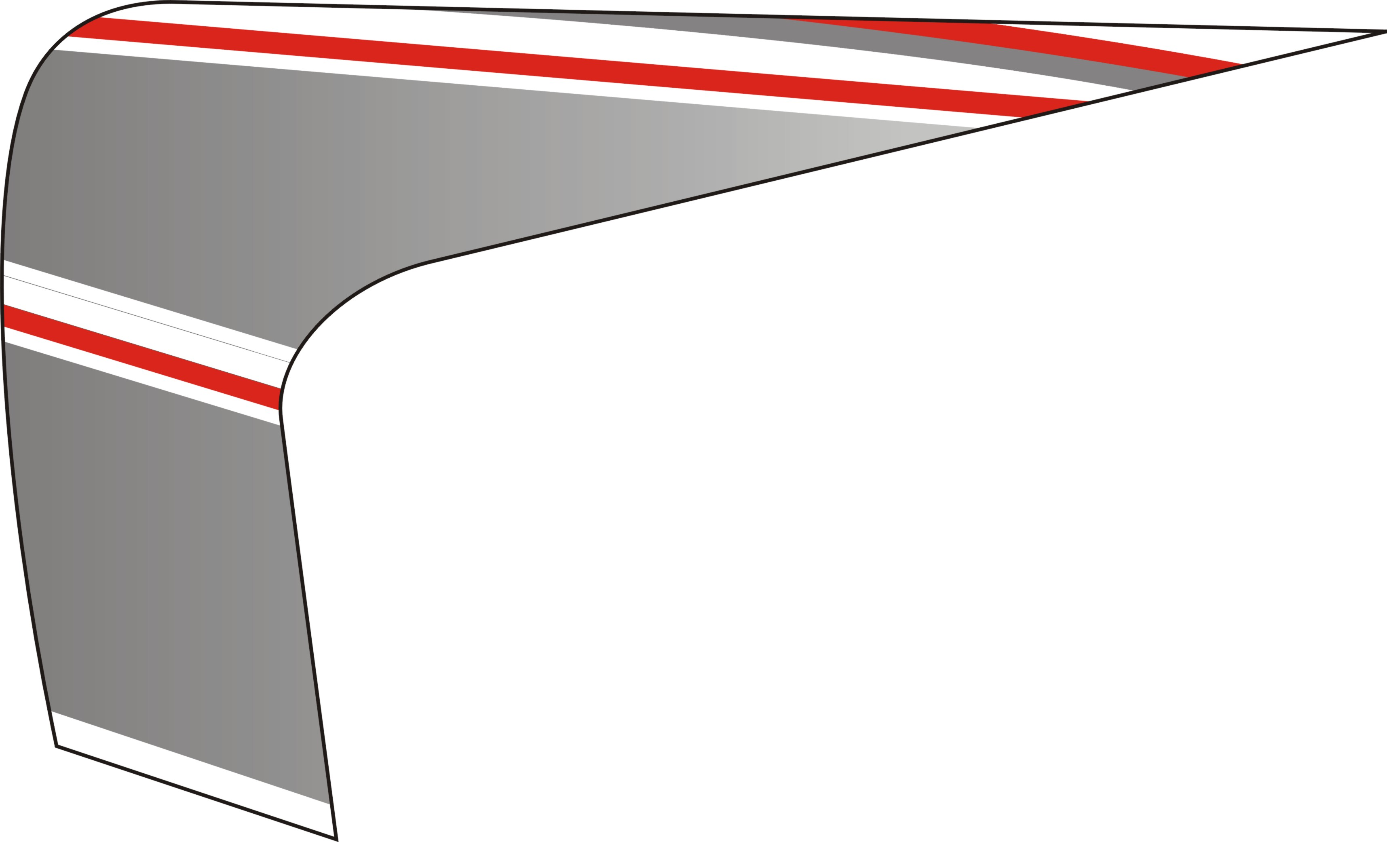 | 513669FR | Label, Side cover,  LH.
 | 513670FR | Label, Side cover,  LH.
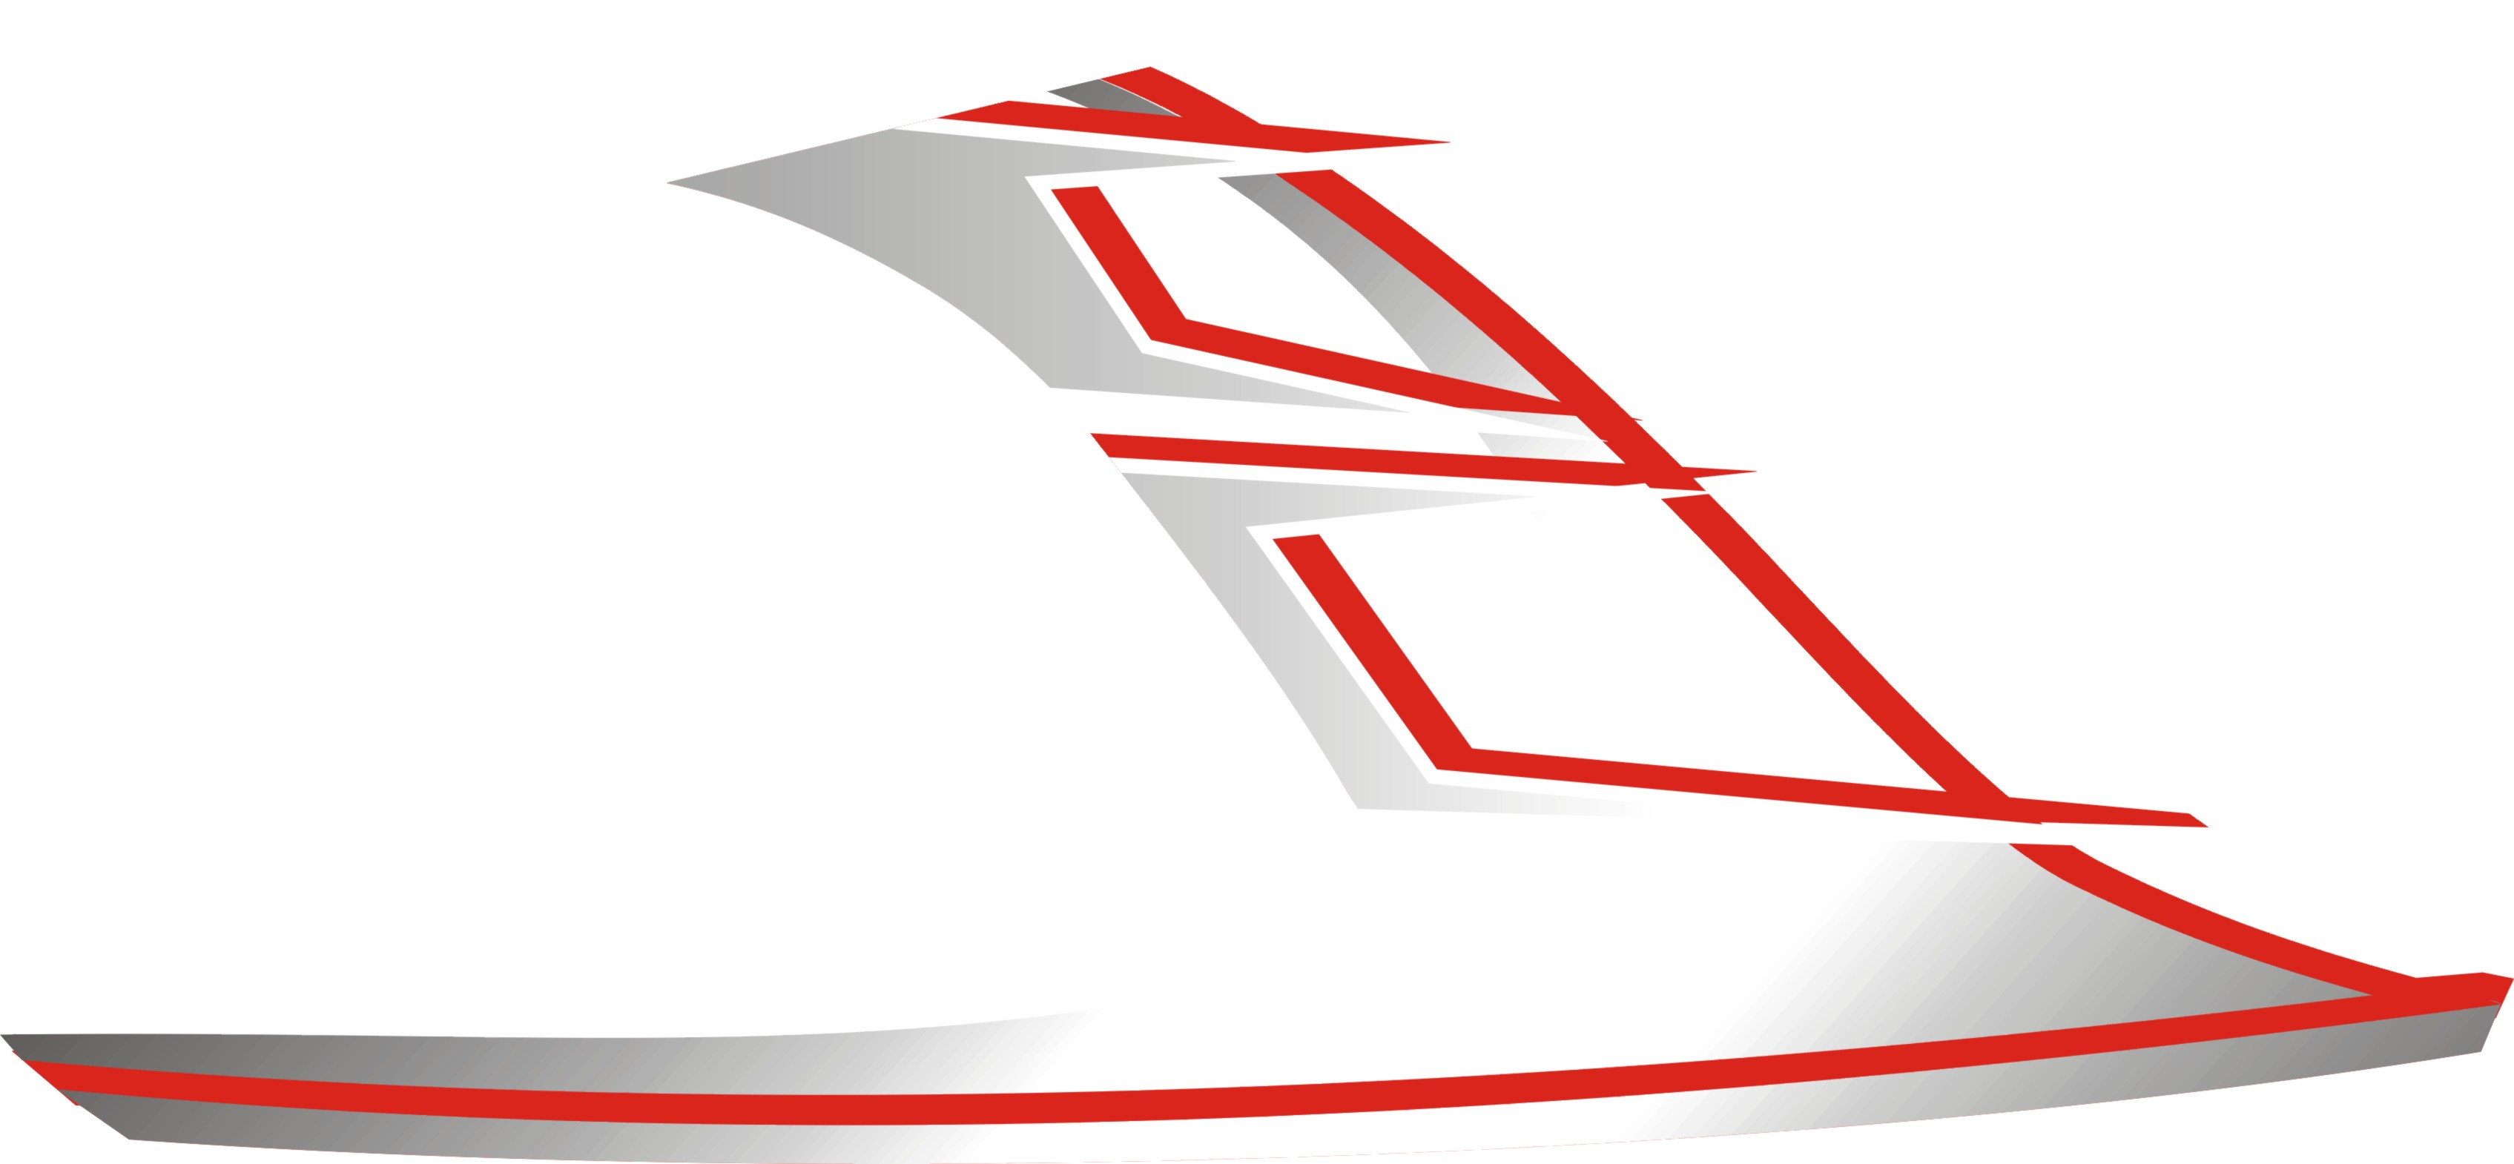 | 514651FR | Label, Side cover,  LH.
 | 513672FR | Label, Side cover,  RH.
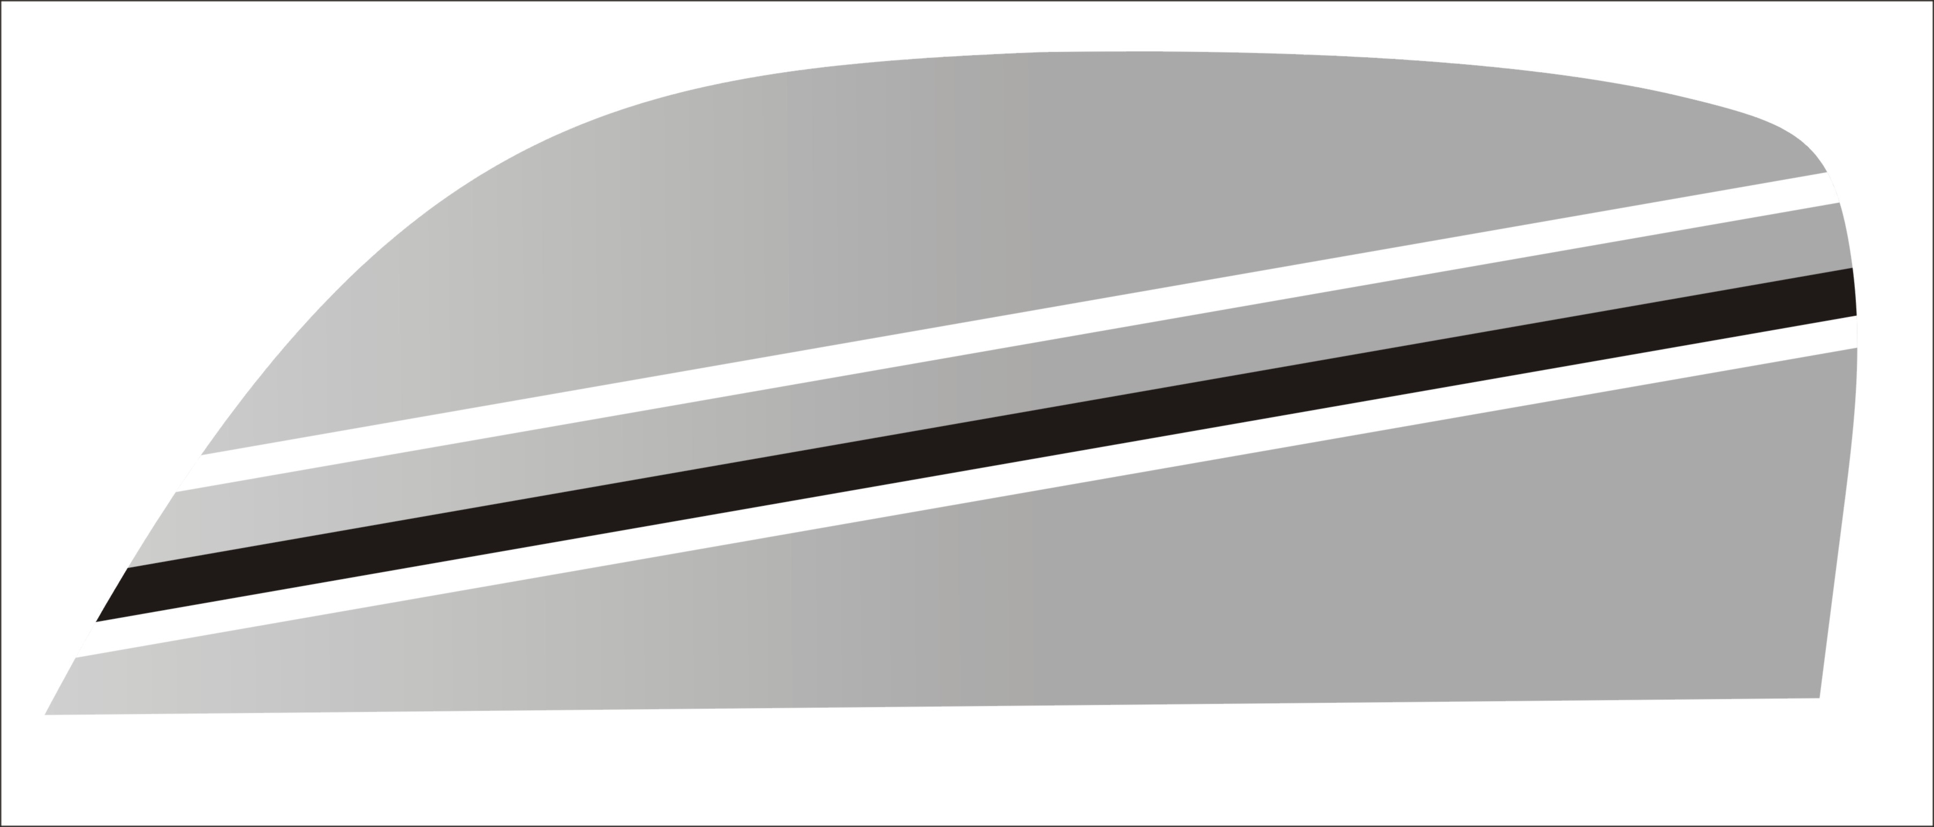 | 513673FR | Label, Side cover,  RH.
 | 514652FR | Label, Side cover,  RH.
 | 513675FR | “BLAND” Label
 | 514677FR | “325” Label

FCC TABLE OF LABEL
Label | Drawing | Description
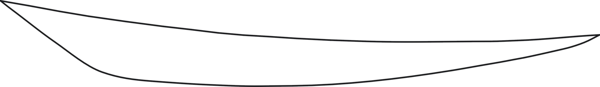 | 459416WH | Emblem, Rear cover,  LH.
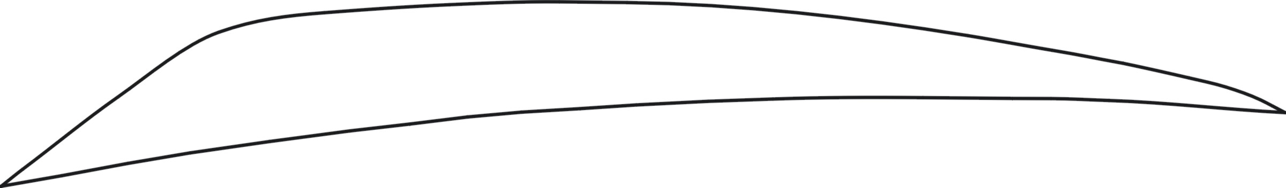 | 459417WH | Emblem, Rear cover,  RH.

