FBG-DE TABLE OF COLORED PART 2011
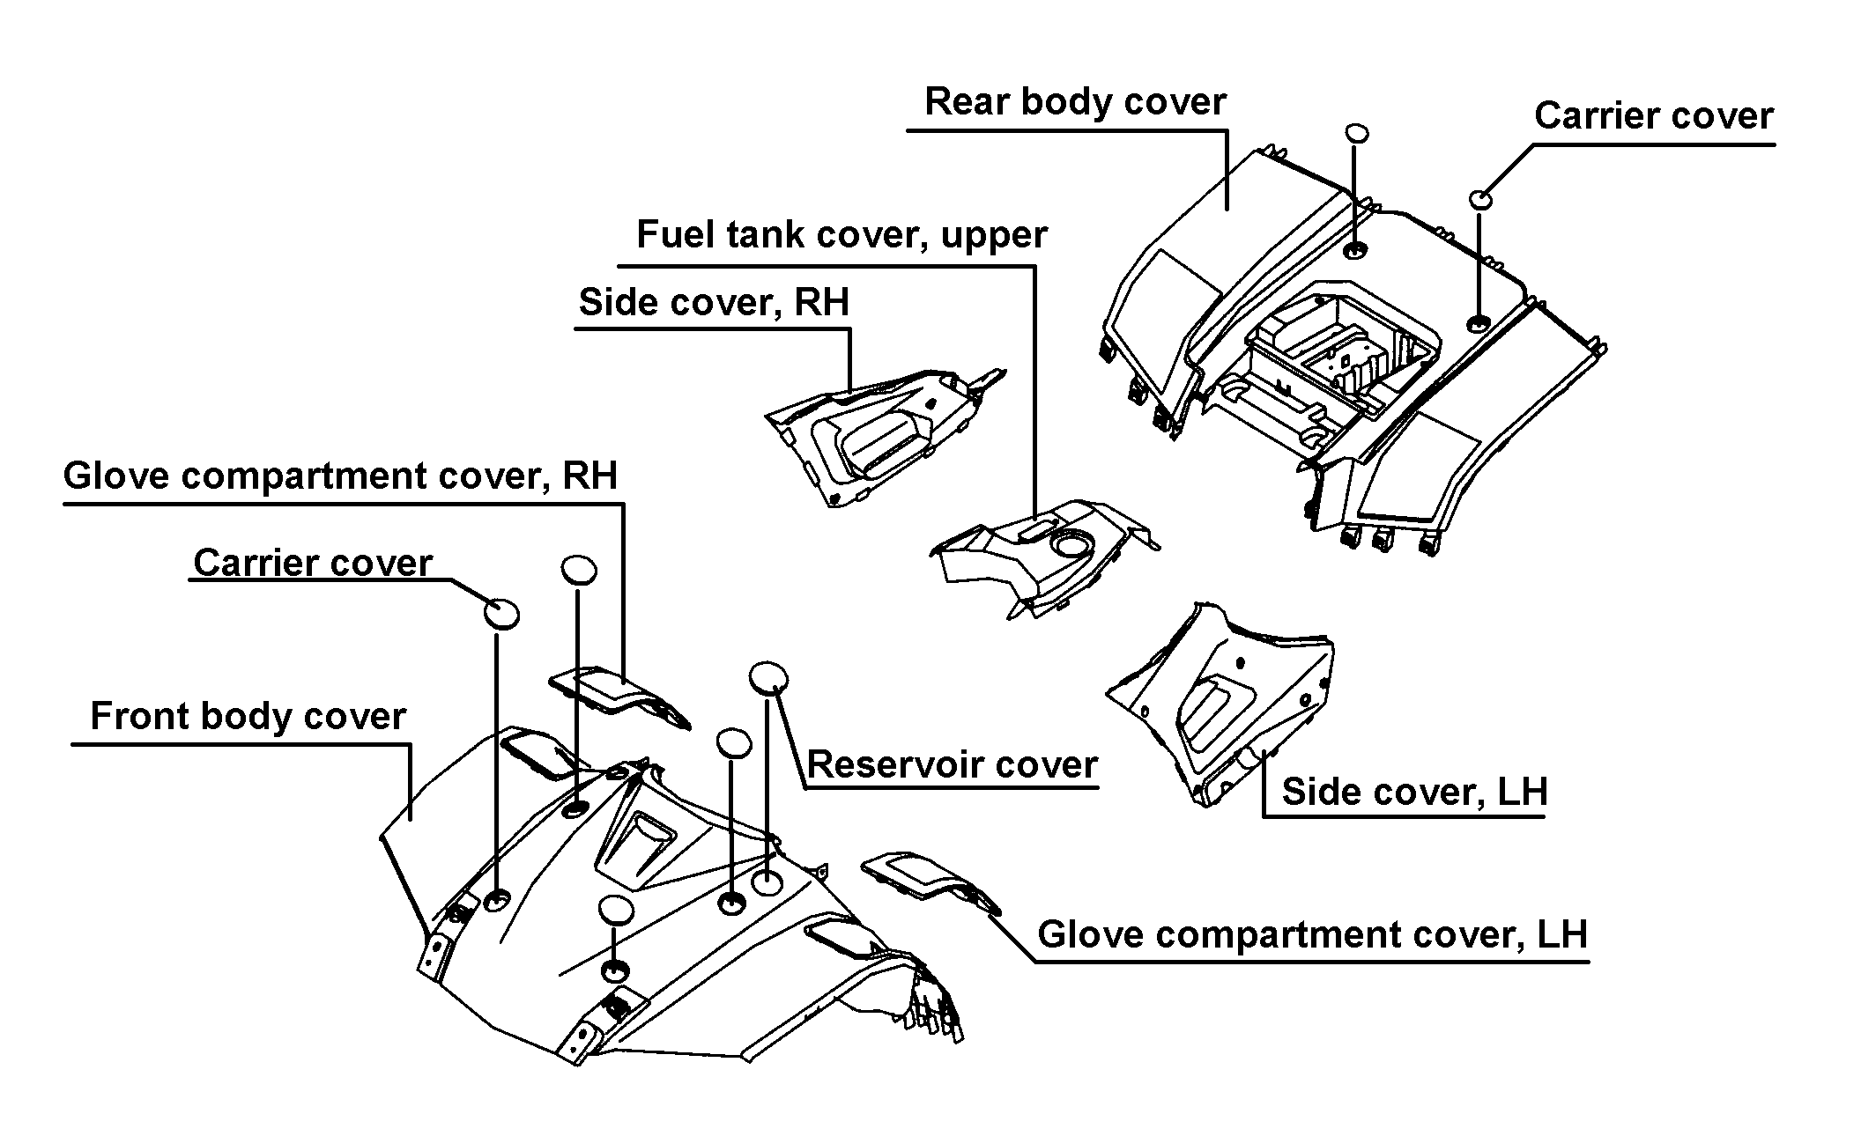
TABLE OF COLORED PART（Blade 550i SE 4X4）
ITEM | CODE | A | B | C | D | E
NO. | Basic Color | Black | Red | White | Silver Gray | Orange
 | Description | BL | RD | WH | SG | OR
 | Front body cover, With emblem | 512465BLF6 | 512465RDFB | 512465WHF3 | 512465SGF4 | 512465ORF5
 | Front body cover | 512465BL | 512465RD | 512465WH | 512465SG | 512465OR
 | Emblem | 516685BL | 516685RDA | 516685WH | 516685SG | 516685OR
 | Emblem | 516686BL | 516686RDA | 516686WH | 516686SG | 516686OR
B21 | Emblem | 516687BL | 516687RDA | 516687WH | 516687SG | 516687OR
 | Glove compartment cover, LH | 512421BL | 512421RD | 512421WH | 512421SG | 512421OR
 | Glove compartment cover, RH | 512422BL | 512422RD | 512422WH | 512422SG | 512422OR
 | Carrier cover | 512425BL | 512425RD | 512425WH | 512425SG | 512425OR
 | Reservoir cover | 512424BL | 512424RD | 512424WH | 512424SG | 512424OR
 | Side cover, LH, With emblem | 512540CALA8 | 512540CALA9 | 512540CALAA | 512540CALAB | 512540CALAC
 | Side cover, LH | 512540CA | 512540CA | 512540CA | 512540CA | 512540CA
 | Emblem | 516689BL | 516689RDA | 516689WH | 516689SG | 516689OR
 | Emblem | 516690BL | 516690RDA | 516690WH | 516690SG | 516690OR
 | Emblem | 516691BL | 516691RDA | 516691WH | 516691SG | 516691OR
 | Emblem | 516692BL | 516692RDA | 516692WH | 516692SG | 516692OR
 | Emblem | 517065BL | 517065RDA | 517065WH | 517065SG | 517065OR
B22 | Side cover, RH, With emblem | 512541CBRA8 | 512541CBRA9 | 512541CBRAA | 512541CBRAB | 512541CBRAC
 | Side cover, RH | 512541CB | 512541CB | 512541CB | 512541CB | 512541CB
 | Emblem | 516694BL | 516694RDA | 516694WH | 516694SG | 516694OR
 | Emblem | 516695BL | 516695RDA | 516695WH | 516695SG | 516695OR
 | Emblem | 516696BL | 516696RDA | 516696WH | 516696SG | 516696OR
 | Emblem | 516697BL | 516697RDA | 516697WH | 516697SG | 516697OR
 | Emblem | 517066BL | 517066RDA | 517066WH | 517066SG | 517066OR
 | Fuel tank cover, upper | 512539C | 512539C | 512539C | 512539C | 512539C
 | Rear body cover, With emblem | 514459GBLR9 | 514459GRDRC | 514459GWHR5 | 514459GSGR4 | 514459GORR6
 | Rear body cover | 514459GBL | 514459GRD | 514459GWH | 514459GSG | 514459GOR
B23 | Emblem | 516699BL | 516699RDA | 516699WH | 516699SG | 516699OR
 | Emblem | 516700BL | 516700RDA | 516700WH | 516700SG | 516700OR
 | Carrier cover | 512425BL | 512425RD | 512425WH | 512425SG | 512425OR

Ⅰ
FBG-DE TABLE OF LABEL 2011

Label | Drawing | Description
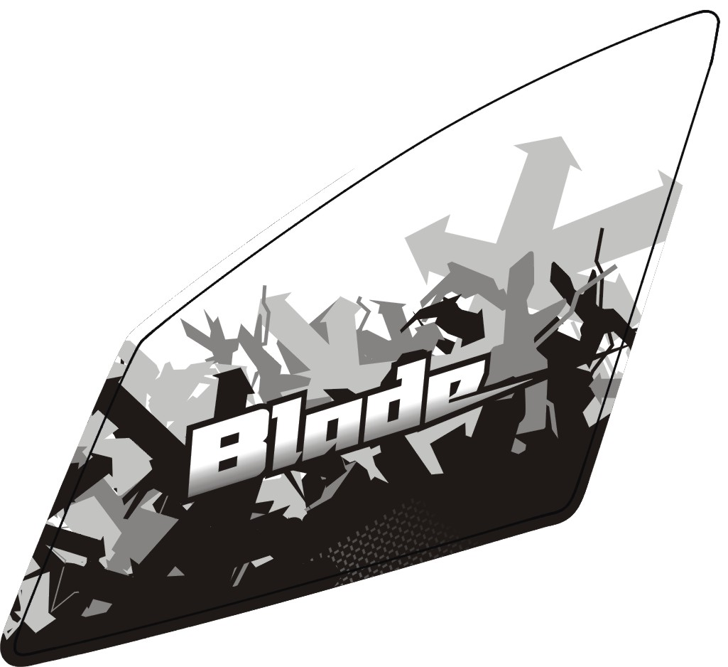 | 516685BL  516685RDA  516685WH  516685SG  516685OR | Emblem, Front body cover.
 | 516686BL  516686RDA  516686WH  516686SG  516686OR | Emblem, Front body cover.
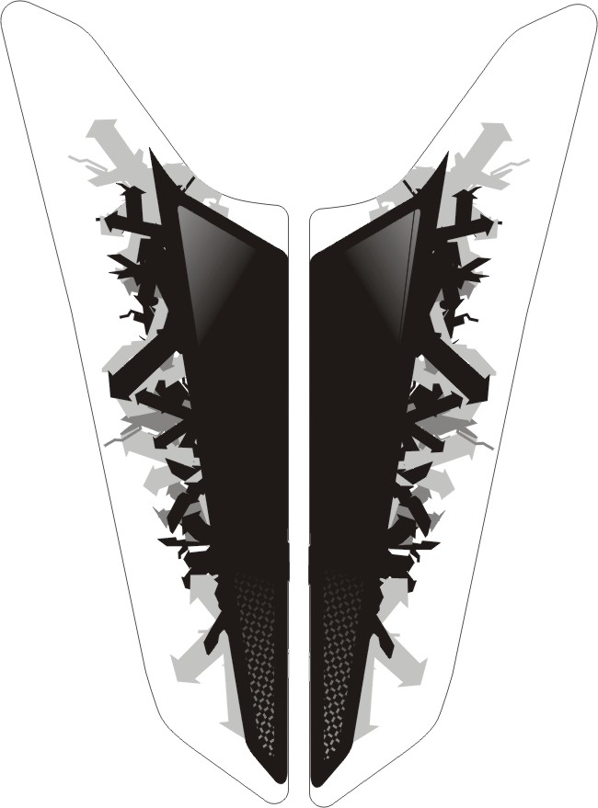 | 516687BL  516687RDA  516687WH  516687SG  516687OR | Emblem, Front body cover.
 | 516689BL  516689RDA  516689WH  516689SG  516689RO | Emblem, Side cover, LH.
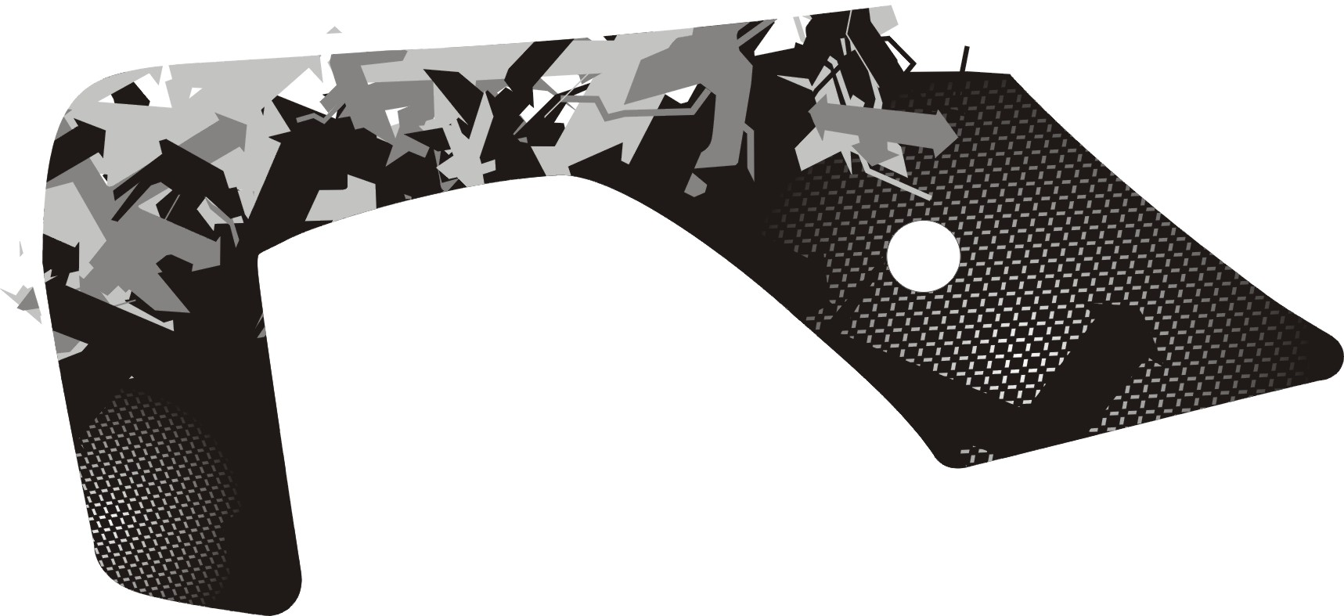 | 516690BL  516690RDA  516690WH  516690SG  516690OR | Emblem, Side cover, LH.
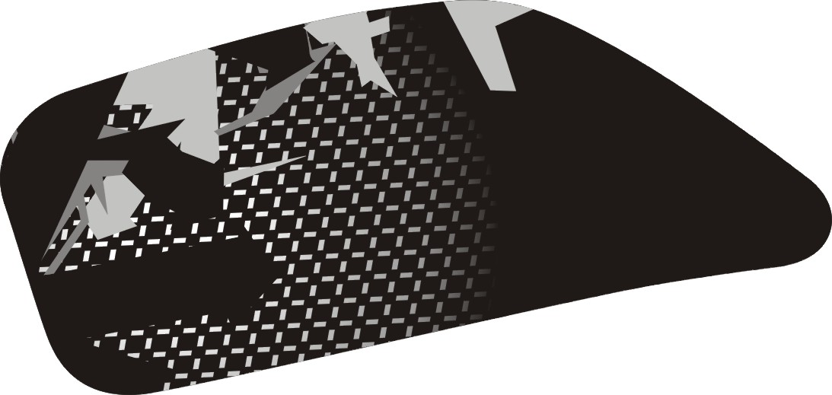 | 516691BL  516691RDA  516691WH  516691SG  516691OR | Emblem, Side cover, LH.
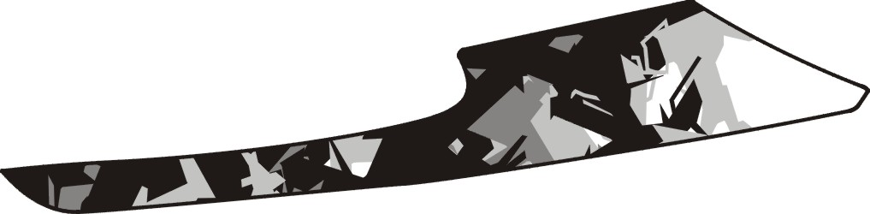 | 516692BL  516692RDA  516692WH  516692SG  516692OR | Emblem, Side cover, LH.
I
FBG-DE TABLE OF LABEL 2011

Label | Drawing | Description
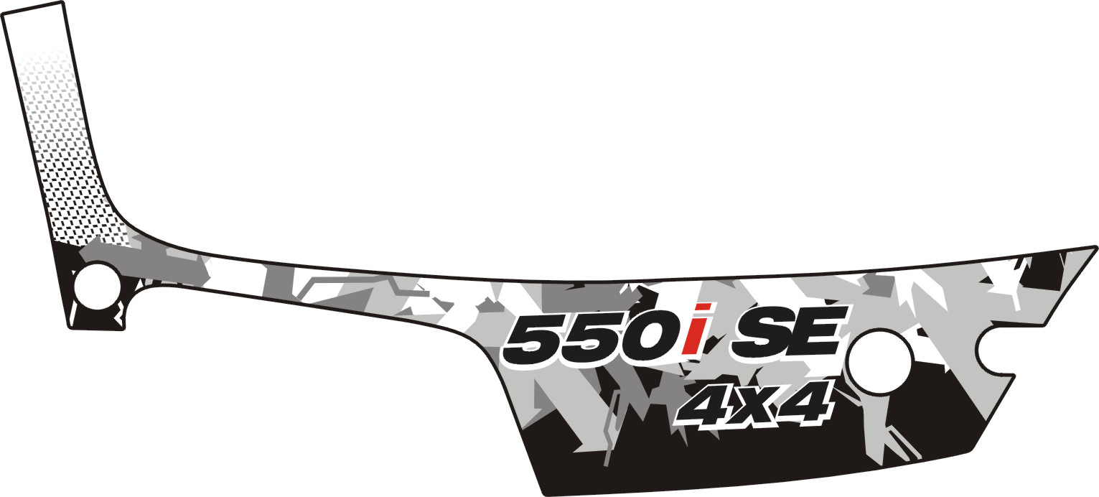 | 517065BL  517065RDA  517065WH  517065SG  517065OR | Emblem, Side cover, LH.
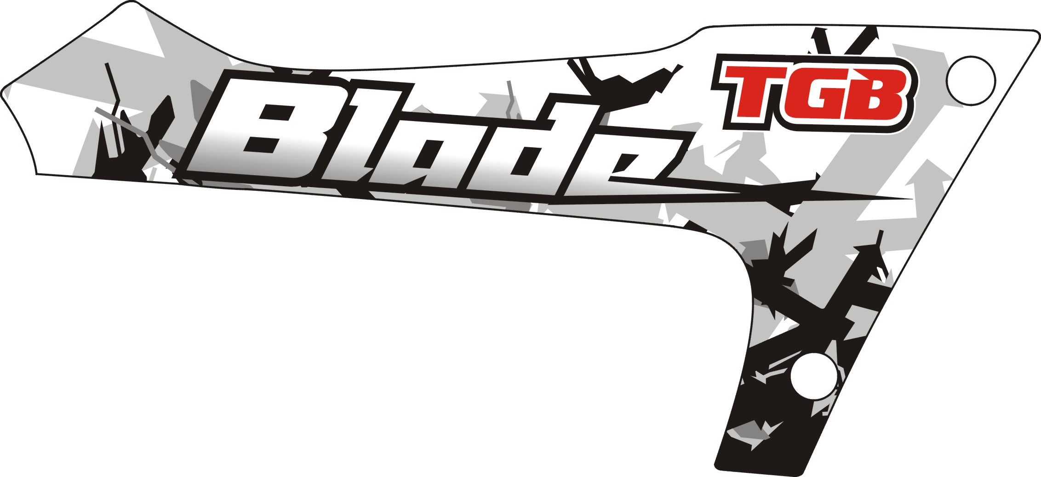 | 516694BL  516694RDA  516694WH  516694SG  516694OR | Emblem, Side cover, RH.
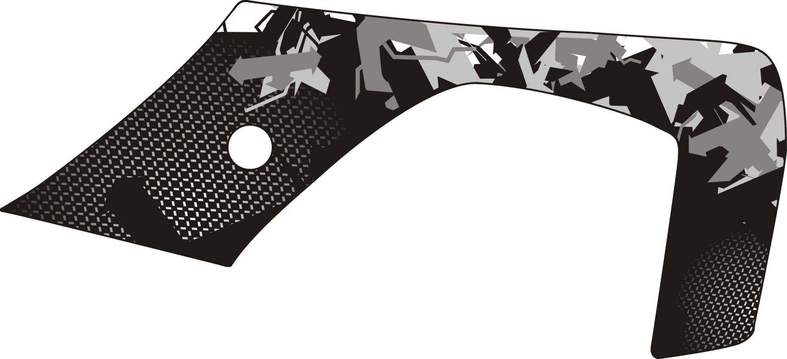 | 516695BL  516695RDA  516695WH  516695SG  516695OR | Emblem, Side cover, RH.
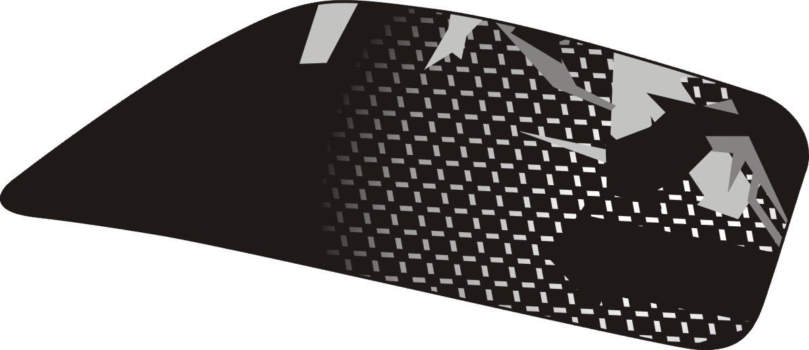 | 516696BL  516696RDA  516696WH  516696SG  516696OR | Emblem, Side cover, RH.
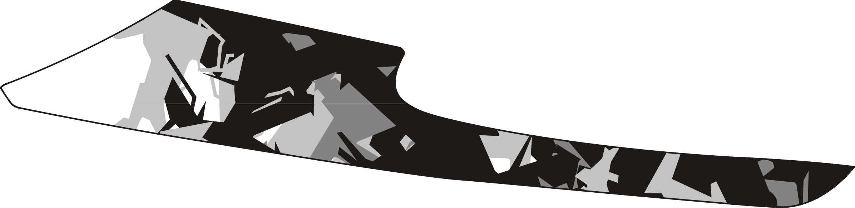 | 516697BL  516697RDA  516697WH  516697SG  516697OR | Emblem, Side cover, RH.
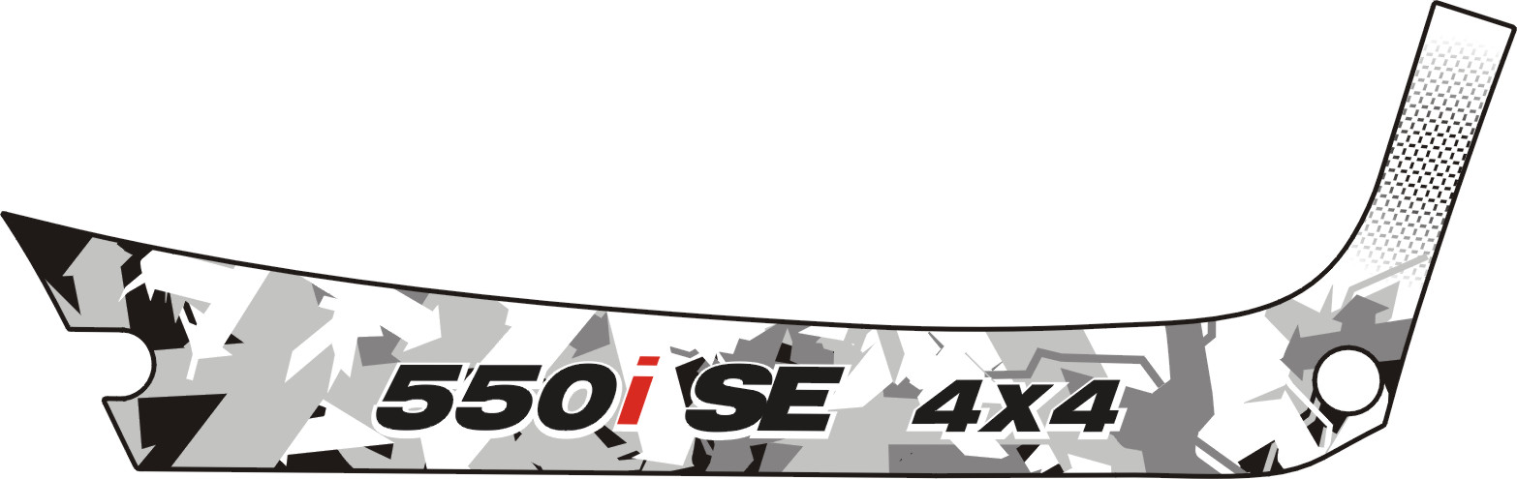 | 517066BL  517066RDA  517066WH  517066SG  517066OR | Emblem, Side cover, RH.

II
FBG-DE TABLE OF LABEL 2011
Label | Drawing | Description
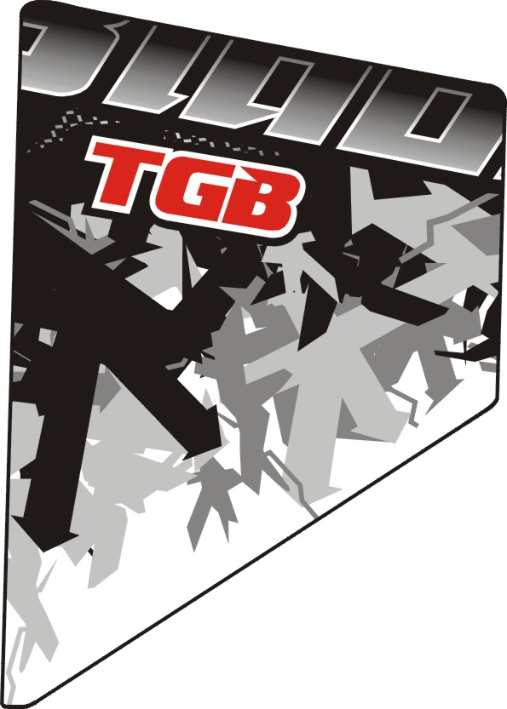 | 516699BL  516699RDA  516699WH  516699SG  516699OR | Emblem,Rear cover, LH.
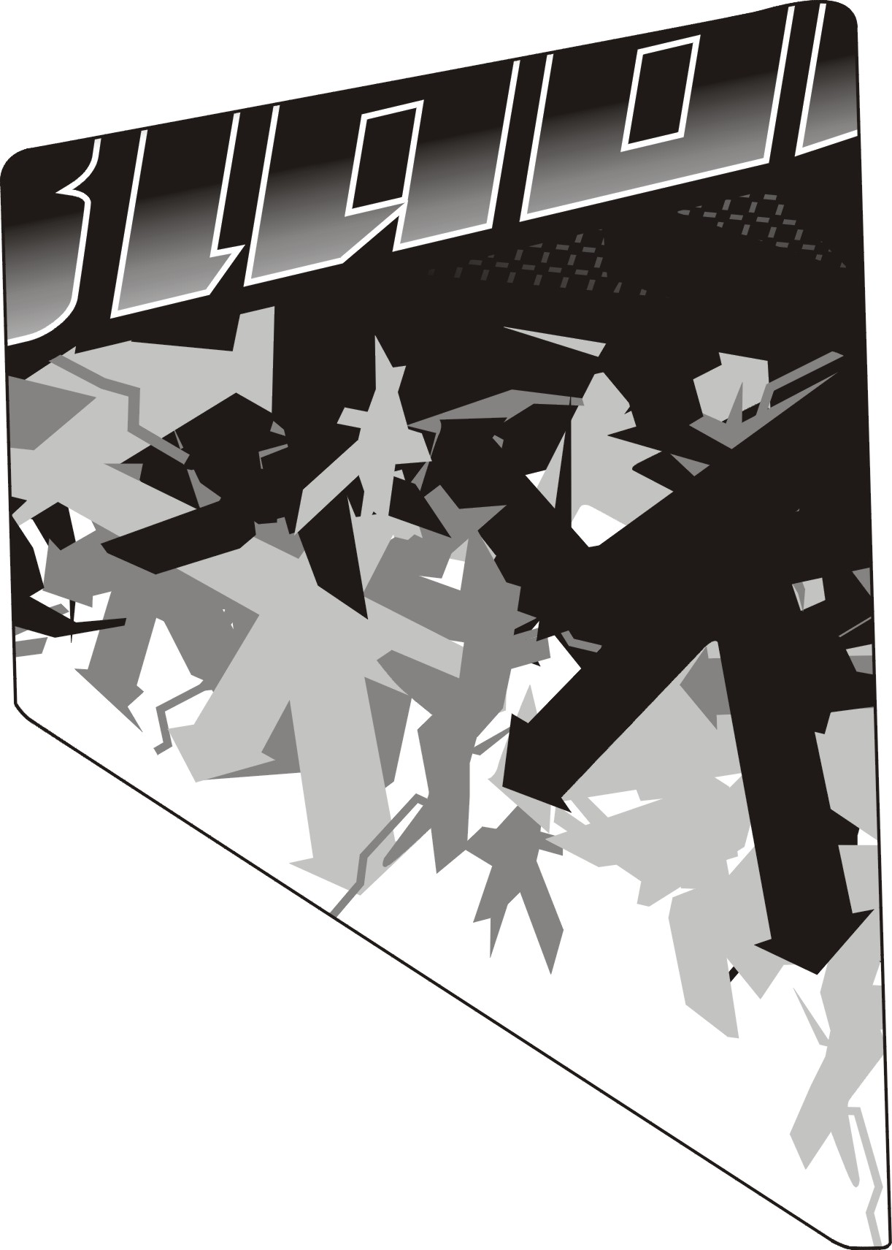 | 516700BL  516700RDA  516700WH  516700SG  516700OR | Emblem,Rear cover, RH.

III

