FBG-DL TABLE OF COLORED PART 2010
FOR CZECHOSLOVAKIA

TABLE OF COLORED PART（Blade 550LT,4×4）
ITEM | CODE | A | B | C
NO. | Basic Color | Black | White | Orange
 | Description | BL | WH | OR
B01 | Cover, Handle Bar, Front | 513103BL | 513103WH | 513103OR
 | Front body cover, With emblem | 512465BLF6 | 512465WHF3 | 512465ORF8
 | Front body cover | 512465BL | 512465WH | 512465OR
 | Emblem | 516685BL | 516685WH | 516685OR
 | Emblem | 516686BL | 516686WH | 516686OR
B21 | Emblem | 516687BL | 516687WH | 516687OR
 | Glove compartment cover, LH | 512421BL | 512421WH | 512421OR
 | Glove compartment cover, RH | 512422BL | 512422WH | 512422OR
 | Carrier cover | 512425BL | 512425WH | 512425OR
 | Reservoir cover | 512424BL | 512424WH | 512424OR
 | Side cover, LH, With emblem | 512546CBLL1 | 512546CWHL2 | 512546CORL3
 | Side cover, LH | 512546CBL | 512546CWH | 512546COR
 | Emblem | 516764BL | 516764WH | 516764OR
 | Emblem | 516765BL | 516765WH | 516765OR
 | Emblem | 516766BL | 516766WH | 516766OR
 | Emblem | 516715BL | 516715WH | 516715OR
 | Emblem | 516691BL | 516691WH | 516691OR
B22 | Side cover, RH, With emblem | 512547CABLR1 | 512547CAWHR2 | 512547CAORR3
 | Side cover, RH | 512547CABL | 512547CAWH | 512547CAOR
 | Emblem | 516768BL | 516768WH | 516768OR
 | Emblem | 516769BL | 516769WH | 516769OR
 | Emblem | 516770BL | 516770WH | 516770OR
 | Emblem | 516716BL | 516716WH | 516716OR
 | Emblem | 516696BL | 516696WH | 516696OR
 | Fuel tank cover, upper, With emblem | 512545BLF1 | 512545WHF2 | 512545ORF3
 | Fuel tank cover, upper | 512545BL | 512545WH | 512545OR
 | Emblem | 516763BL | 516763WH | 516763OR
 | Emblem | 516767BL | 516767WH | 516767OR
 | Rear body cover, With emblem | 514459GBLR1 | 514459GWHR2 | 514459GORR3
 | Rear body cover | 514459GBL | 514459GWH | 514459GOR
B23 | Emblem | 516699BL | 516699WH | 516699OR
 | Emblem | 516700BL | 516700WH | 516700OR
 | Carrier cover | 512425BL | 512425WH | 512425OR
Ⅰ
FBG-DL TABLE OF LABEL
Label | Drawing | Description
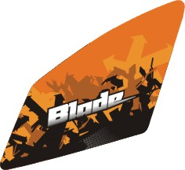 | 516685BL  516685WH  516685OR | Emblem, Front body cover
 | 516686BL  516686WH  516686OR | Emblem, Front body cover
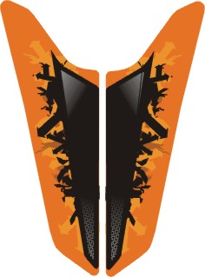 | 516687BL  516687WH  516687OR | Emblem, Front body cover
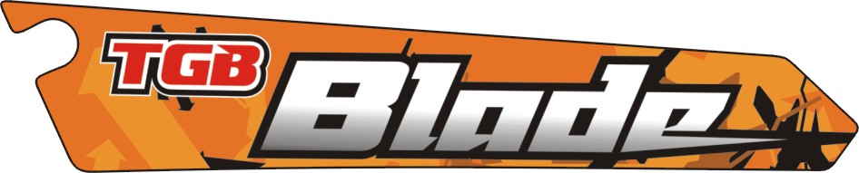 | 516763BL  516763WH  516763OR | Emblem, Side cover, LH.
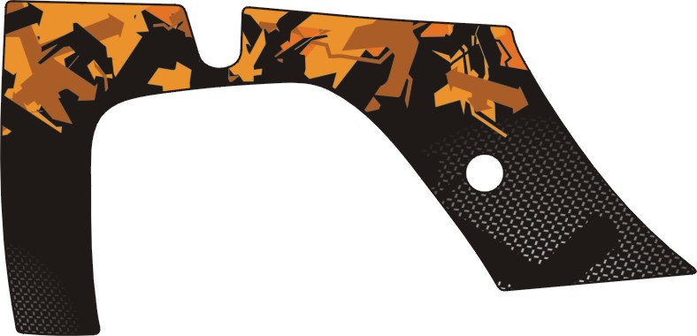 | 516764BL  516764WH  516764OR | Emblem, Side cover, LH.
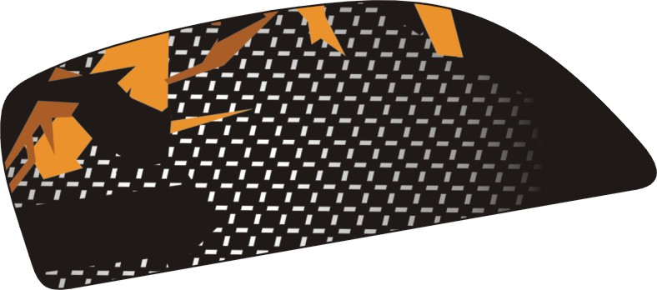 | 516691BL  516691WH  516691OR | Emblem, Side cover,LH.
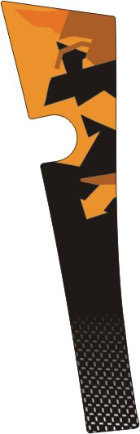 | 516765BL  516765WH  516765OR | Emblem, Side cover, LH.

FBG-DL TABLE OF LABEL
Label | Drawing | Description
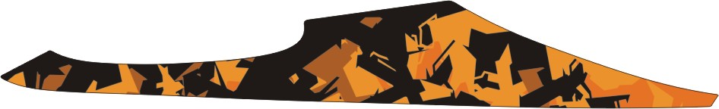 | 516766BL  516766WH  516766OR | Emblem, Side cover, LH.
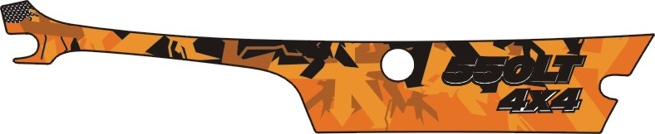 | 516715BL  516715WH  516715OR | Emblem, Side cover, LH.
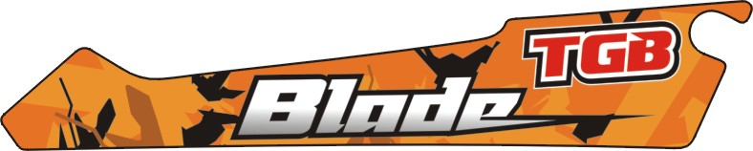 | 516767BL  516767WH  516767OR | Emblem, Side cover, RH.
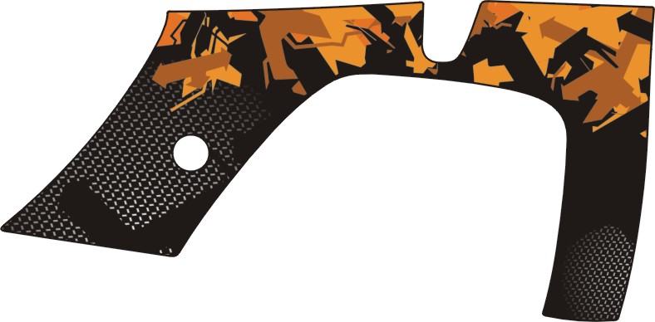 | 516768BL  516768WH  516768OR | Emblem, Side cover, RH.
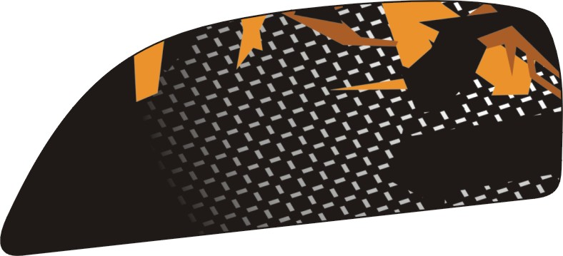 | 516696BL  516696WH  516696OR | Emblem, Side cover, RH.
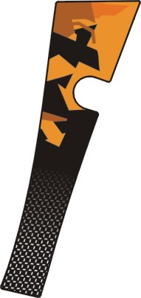 | 516769BL  516769WH  516769OR | Emblem, Side cover, RH.
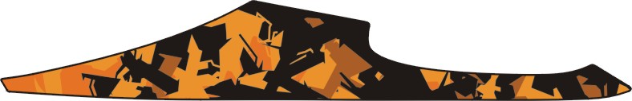 | 516770BL  516770WH  516770OR | Emblem, Side cover, RH.
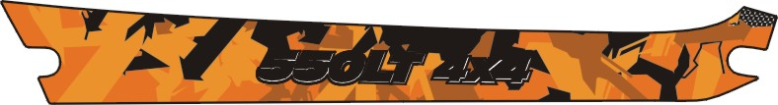 | 516716BL  516716WH  516716OR | Emblem, Side cover, RH.

FBG-DL TABLE OF LABEL
Label | Drawing | Description
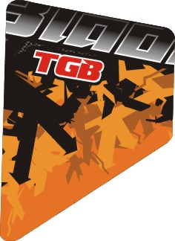 | 516699BL  516699WH  516699OR | Emblem,Rear cover,LH.
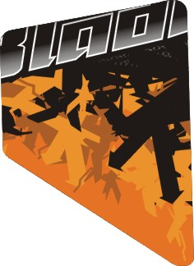 | 516700BL  516700WH  516700OR | Emblem,Rear cover,RH.

