FBG TABLE OF COLORED PART 2008
FOR CZECHOSLOVAKIA

TABLE OF COLORED PART（Blade 525SL,4×4）
ITEM | CODE | A | B | C | D | E
NO. | Basic Color | Red | Blue | Black | Yellow | Olive Green
 | Description | RD | BE | BL | YE | OG
B01 | Cover, Handle Bar, Front | 513103RD | 513103BE | 513103BL | 513103YE | 513103OG
B13 | Rim Comp., Front | 512920MBY | 512920MBY | 512920MBY | 512920MBY | 512920MBY
B19 | Rim Comp., Rear | 513405MBY | 513405MBY | 513405MBY | 513405MBY | 513405MBY
 | Front body cover, With emblem | 512415RDF2 | 512415BEF2 | 512415BLF2 | 512415YEF2 | 512415OGF2
 | Front body cover | 512415RD | 512415BE | 512415BL | 512415YE | 512415OG
 | Emblem | 514682 | 514682 | 514682 | 514682 | 514682
 | Emblem | 514683 | 514683 | 514683 | 514683 | 514683
B21 | Emblem | 514684 | 514684 | 514684 | 514684 | 514684
 | Glove compartment cover, LH | 512421RD | 512421BE | 512421BL | 512421YE | 512421OG
 | Glove compartment cover, RH | 512422RD | 512422BE | 512422BL | 512422YE | 512422OG
 | Carrier cover | 512425RD | 512425BE | 512425BL | 512425YE | 512425OG
 | Reservoir cover | 512424RD | 512424BE | 512424BL | 512424YE | 512424OG
 | Side cover, LH, With emblem | 512522ARDLK | 512522ABELK | 512522ABLLK | 512522AYELK | 512522AOGLK
 | Side cover, LH | 512522ARD | 512522ABE | 512522ABL | 512522AYE | 512522AOG
 | Emblem | 514696 | 514696 | 514696 | 514696 | 514696
 | Emblem | 514689 | 514689 | 514689 | 514689 | 514689
 | Emblem | 514690 | 514690 | 514690 | 514690 | 514690
 | Emblem | 515639 | 515639 | 515639 | 515639 | 515639
B22 | Side cover, RH, With emblem | 512523ARDRK | 512523ABERK | 512523ABLRK | 512523AYERK | 512523AOGRK
 | Side cover, RH | 512523ARD | 512523ABE | 512523ABL | 512523AYE | 512523AOG
 | Emblem | 514697 | 514697 | 514697 | 514697 | 514697
 | Emblem | 514693 | 514693 | 514693 | 514693 | 514693
 | Emblem | 514694 | 514694 | 514694 | 514694 | 514694
 | Emblem | 515640 | 515640 | 515640 | 515640 | 515640
 | Fuel tank cover, upper | 512505RD | 512505BE | 512505BL | 512505YE | 512505OG
 | Rear body cover, With emblem | 514459BRDR3 | 514459BBER3 | 514459BBLR3 | 514459BYER3 | 514459BOGR3
 | Rear body cover | 514459BRD | 514459BBE | 514459BBL | 514459BYE | 514459BOG
B23 | Emblem | 514685 | 514685 | 514685 | 514685 | 514685
 | Emblem | 514686 | 514686 | 514686 | 514686 | 514686
 | Emblem | 814687 | 814687 | 814687 | 814687 | 814687
 | Carrier cover | 512425RD | 512425BE | 512425BL | 512425YE | 512425OG
Ⅰ
FBG TABLE OF COLORED PART 2008
FOR CZECHOSLOVAKIA

TABLE OF COLORED PART（Blade 525SE,4×4）
ITEM | CODE | A | B | C
NO. | Basic Color | White | Silver Gray | Orange
 | Description | WH | SG | OR
B01 | Cover, Handle Bar, Front | 513103WH | 513103SG | 513103OR
B13 | Rim Comp., Front | 512943MBY | 512943MBY | 512943MBY
B19 | Rim Comp., Rear | 513423MBY | 513423MBY | 513423MBY
 | Front body cover, With emblem | 512415WHF2 | 512415SGF2 | 512415ORF2
 | Front body cover | 512415WH | 512415SG | 512415OR
 | Emblem | 514682 | 514682 | 514682
 | Emblem | 514683 | 514683 | 514683
B21 | Emblem | 514684 | 514684 | 514684
 | Glove compartment cover, LH | 512421WH | 512421SG | 512421OR
 | Glove compartment cover, RH | 512422WH | 512422SG | 512422OR
 | Carrier cover | 512425WH | 512425SG | 512425OR
 | Reservoir cover | 512424WH | 512424SG | 512424OR
 | Side cover, LH, With emblem | 512540CALL | 512540CALL | 512540CALL
 | Side cover, LH | 512540CA | 512540CA | 512540CA
 | Emblem | 514696 | 514696 | 514696
 | Emblem | 514689 | 514689 | 514689
 | Emblem | 514690 | 514690 | 514690
 | Emblem | 515641 | 515641 | 515641
B22 | Side cover, RH, With emblem | 512541CARL | 512541CARL | 512541CARL
 | Side cover, RH | 512541CA | 512541CA | 512541CA
 | Emblem | 514697 | 514697 | 514697
 | Emblem | 514693 | 514693 | 514693
 | Emblem | 514694 | 514694 | 514694
 | Emblem | 515642 | 515642 | 515642
 | Fuel tank cover, upper | 512539C | 512539C | 512539C
 | Rear body cover, With emblem | 514459BWHR3 | 514459BSGR3 | 514459BORR3
 | Rear body cover | 514459BWH | 514459BSG | 514459BOR
B23 | Emblem | 514685 | 514685 | 514685
 | Emblem | 514686 | 514686 | 514686
 | Emblem | 814687 | 814687 | 814687
 | Carrier cover | 512425WH | 512425SG | 512425OR
Ⅰ
FBG TABLE OF LABEL
Label | Drawing | Description
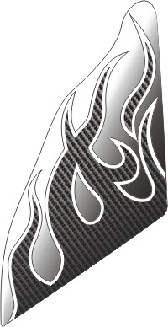 | 514682 | Emblem, Front body cover
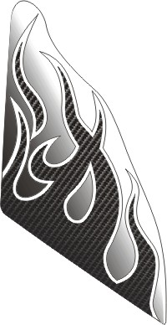 | 514683 | Emblem, Front body cover
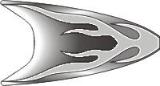 | 514684 | Emblem, Front body cover
 | 514685 | Emblem, Rear cover
 | 514686 | Emblem, Rear cover
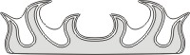 | 514687 | Emblem, Rear cover
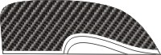 | 514689 | Emblem, Side cover, LH.
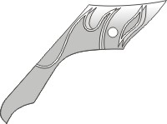 | 514690 | Emblem, Side cover, LH.

FBG TABLE OF LABEL
Label | Drawing | Description
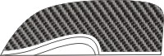 | 514693 | Emblem, Side cover, RH.
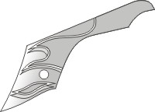 | 514694 | Emblem, Side cover, RH.
 | 514696 | Emblem, Side cover, LH.
 | 514697 | Emblem, Side cover, RH.
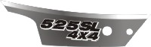 | 515639 | Emblem, Side cover, LH.
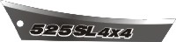 | 515640 | Emblem, Side cover, RH.
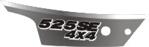 | 515641 | Emblem, Side cover, LH.
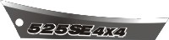 | 515642 | Emblem, Side cover, RH.

