FBG-HDLE TABLE OF COLORED PART 2013

TABLE OF COLORED PART（New Blade 550i LT 4X4）
ITEMNO. | CODE | A | B | C
ITEMNO. | Basic Color | Black | White | Orange
ITEMNO. | Description | BL | WH | OR
B01 | Cover, Handle Bar, Front., With emblem | 513103BLFA | 513103WHFA | 513103ORFA
B01 | Cover, Handle Bar, Front | 513103BL | 513103WH | 513103OR
B01 | Emblem | 517521 | 517521 | 517521
B21 | Front body cover, With emblem | 512465EBLFA | 512465EWHFB | 512465EORFL
B21 | Front body cover | 512465EBL | 512465EWH | 512465EOR
B21 | Emblem | 517263BL | 517263WH | 517263OR
B21 | Emblem | 517264BL | 517264WH | 517264OR
B21 | Glove compartment cover, LH | 512421BL | 512421WH | 512421OR
B21 | Glove compartment cover, RH | 512422BL | 512422WH | 512422OR
B21 | Carrier cover | 512425BL | 512425WH | 512425OR
B21 | Reservoir cover | 512424BL | 512424WH | 512424OR
B22 | Side cover, LH, With emblem | 512546BLLS | 512546WHLT | 512546ORLW
B22 | Side cover, LH | 512546BL | 512546WH | 512546OR
B22 | Emblem | 517290BL | 517290WH | 517290OR
B22 | Emblem | 517291BL | 517291WH | 517291OR
B22 | Emblem | 517292BL | 517292WH | 517292OR
B22 | Emblem | 517519BL | 517519WH | 517519OR
B22 | Emblem | 517293BL | 517293WH | 517293OR
B22 | Side cover, RH, With emblem | 512547ABLRS | 512547AWHRT | 512547AORRW
B22 | Side cover, RH | 512547ABL | 512547AWH | 512547AOR
B22 | Emblem | 517295BL | 517295WH | 517295OR
B22 | Emblem | 517296BL | 517296WH | 517296OR
B22 | Emblem | 517297BL | 517297WH | 517297OR
B22 | Emblem | 517520BL | 517520WH | 517520OR
B22 | Emblem | 517298BL | 517298WH | 517298OR
B22 | Fuel tank cover, upper, With emblem | 512545BLFG | 512545WHFH | 512545ORFL
B22 | Fuel tank cover, upper | 512545BL | 512545WH | 512545OR
B22 | Emblem | 517289BL | 517289WH | 517289OR
B22 | Emblem | 517294BL | 517294WH | 517294OR
B22 | Emblem | 516944 | 516944 | 516944

Ⅰ
FBG-HDLE TABLE OF COLORED PART 2013

TABLE OF COLORED PART（New Blade 550i LT 4X4）
ITEM NO. | CODE | A | B | C
ITEM NO. | Basic Color | Black | White | Orange
ITEM NO. | Description | BL | WH | OR
B23 | Rear body cover, With emblem | 514459GBLRF | 514459GWHRG | 514459GORRA2
B23 | Rear body cover | 514459GBL | 514459GWH | 514459GOR
B23 | Emblem | 517277BL | 517277WH | 517277OR
B23 | Emblem | 517278BL | 517278WH | 517278OR
B23 | Carrier cover | 512425BL | 512425WH | 512425OR

II
FBG-HDLE TABLE OF COLORED PART 2012

TABLE OF COLORED PART（New Blade 550i LT 4×4）
ITEM NO. | CODE | A | B | C
ITEM NO. | Basic Color | Black | White | Orange
ITEM NO. | Description | BL | WH | OR
B01 | Cover, Handle Bar, Front | 513103BL | 513103WH | 513103OR
B21 | Front body cover, With emblem | 512465EBLF1 | 512465EWHF2 | 512465EORF3
B21 | Front body cover | 512465EBL | 512465EWH | 512465EOR
B21 | Emblem | 517230BL | 517230WH | 517230OR
B21 | Emblem | 517231BL | 517231WH | 517231OR
B21 | Glove compartment cover, LH | 512421BL | 512421WH | 512421OR
B21 | Glove compartment cover, RH | 512422BL | 512422WH | 512422OR
B21 | Carrier cover | 512425BL | 512425WH | 512425OR
B21 | Reservoir cover | 512424BL | 512424WH | 512424OR
B22 | Side cover, LH, With emblem | 512546CBLL4 | 512546CWHL5 | 512546CORL6
B22 | Side cover, LH | 512546CBL | 512546CWH | 512546COR
B22 | Emblem | 516764BL | 516764WH | 516764OR
B22 | Emblem | 516765BL | 516765WH | 516765OR
B22 | Emblem | 516766BL | 516766WH | 516766OR
B22 | Emblem | 517069BL | 517069WH | 517069OR
B22 | Emblem | 516691BL | 516691WH | 516691OR
B22 | Side cover, RH, With emblem | 512547CABLR4 | 512547CAWHR5 | 512547CAORR6
B22 | Side cover, RH | 512547CABL | 512547CAWH | 512547CAOR
B22 | Emblem | 516768BL | 516768WH | 516768OR
B22 | Emblem | 516769BL | 516769WH | 516769OR
B22 | Emblem | 516770BL | 516770WH | 516770OR
B22 | Emblem | 517070BL | 517070WH | 517070OR
B22 | Emblem | 516696BL | 516696WH | 516696OR
B22 | Fuel tank cover, upper, With emblem | 512545CBLF1 | 512545CWHF2 | 512545CORF3
B22 | Fuel tank cover, upper | 512545CBL | 512545CWH | 512545COR
B22 | Emblem | 516763BL | 516763WH | 516763OR
B22 | Emblem | 516767BL | 516767WH | 516767OR
B22 | Emblem | 516944 | 516944 | 516944
B23 | Rear body cover, With emblem | 514459GBLR9 | 514459GWHR5 | 514459GORR6
B23 | Rear body cover | 514459GBL | 514459GWH | 514459GOR
B23 | Emblem | 516699BL | 516699WH | 516699OR
B23 | Emblem | 516700BL | 516700WH | 516700OR
B23 | Carrier cover | 512425BL | 512425WH | 512425OR
Ⅰ
FBG-HDLE TABLE OF LABEL 2013
Label | Drawing | Description
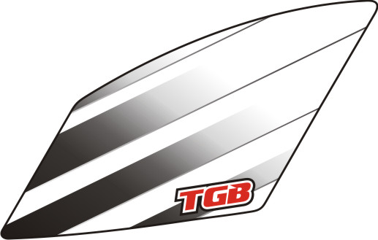 | 517263BL  517263WH  517263OR | Emblem, Front body cover, LH.
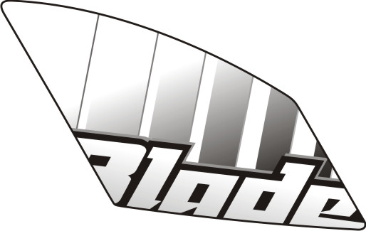 | 517264BL  517264WH  517264OR | Emblem, Front body cover, RH.
 | 517521 | Emblem, Cover, Handle Bar, Front.
 | 517289BL  517289WH  517289OR | Emblem, Fuel tank cover, Upper.
 | 517294BL  517294WH  517294OR | Emblem, Fuel tank cover, Upper.
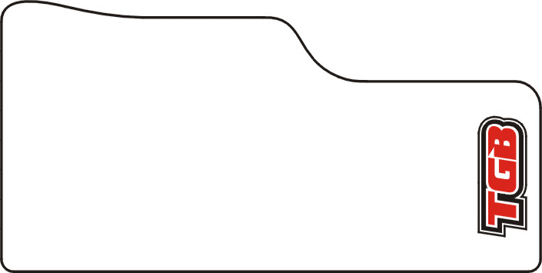 | 516944 | Emblem, Fuel tank cover, Upper.
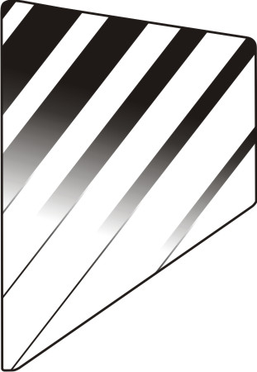 | 517277BL  517277WH  517277OR | Emblem, Rear cover, LH.
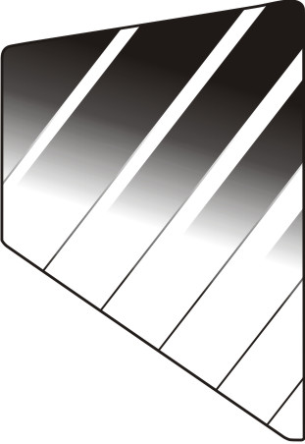 | 517278BL  517278WH  517278OR | Emblem, Rear cover, RH.

I
FBG-HDLE TABLE OF LABEL 2013
Label | Drawing | Description
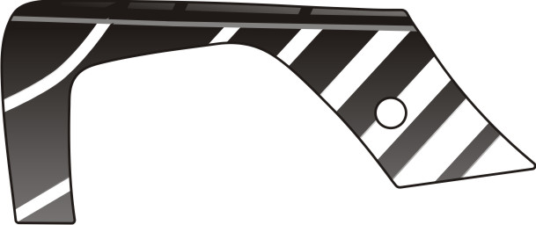 | 517290BL  517290WH  517290OR | Emblem, Side cover, LH.
 | 517291BL  517291WH  517291OR | Emblem, Side cover, LH.
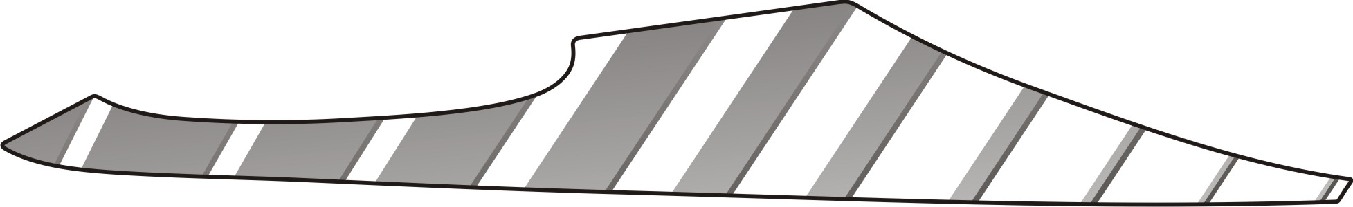 | 517292BL  517292WH  517292OR | Emblem, Side cover, LH.
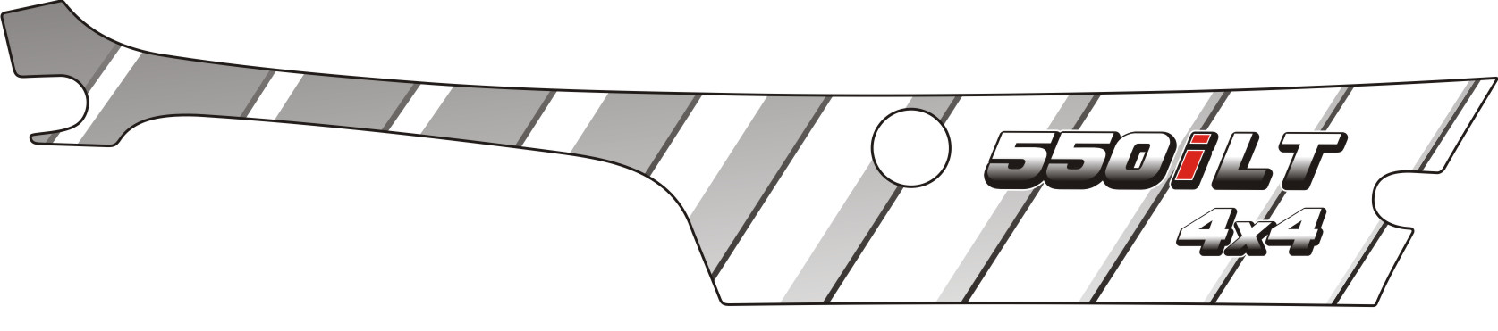 | 517519BL  517519WH  517519OR | Emblem, Side cover, LH.
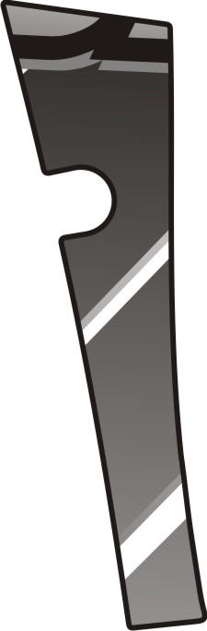 | 517293BL  517293WH  517293OR | Emblem, Side cover, LH.
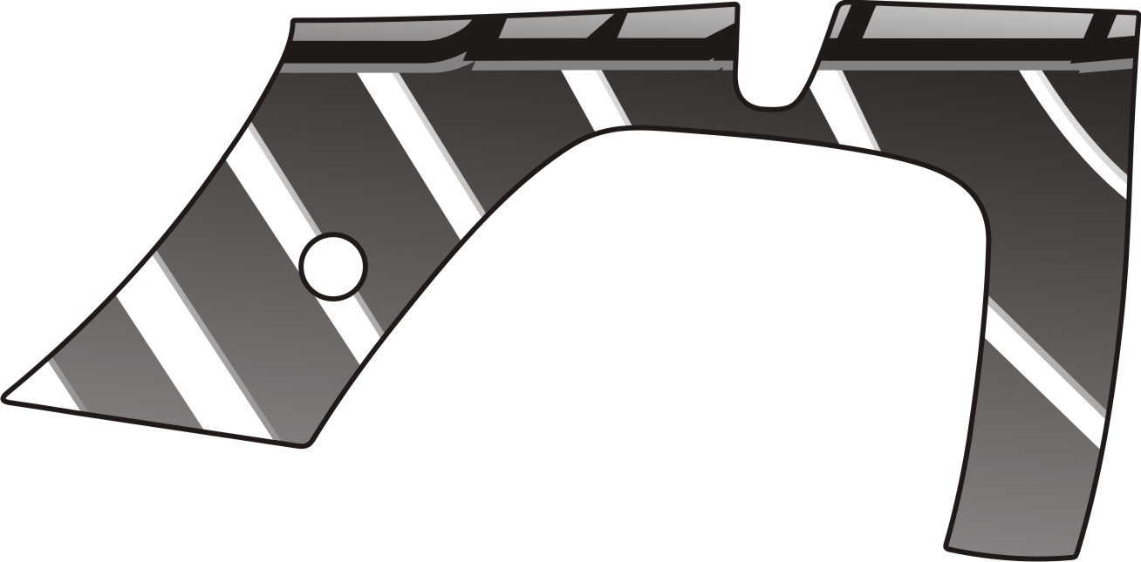 | 517295BL  517295WH  517295OR | Emblem, Side cover, RH.
 | 517296BL  517296WH  517296OR | Emblem, Side cover, RH.
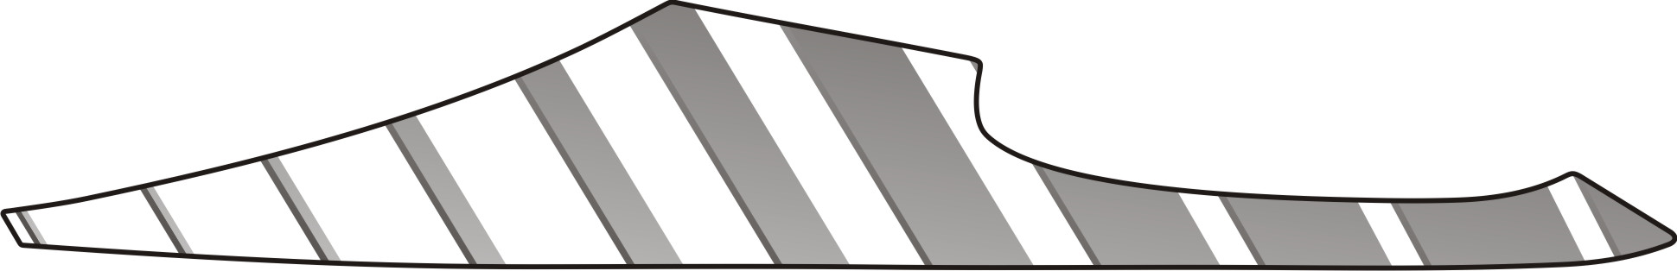 | 517297BL  517297WH  517297OR | Emblem, Side cover, RH.
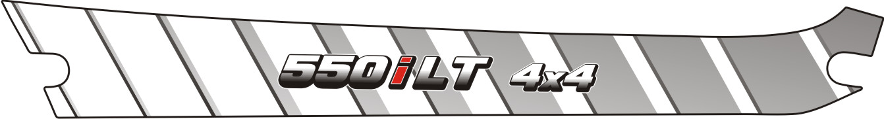 | 517520BL  517520WH  517520OR | Emblem, Side cover, RH.
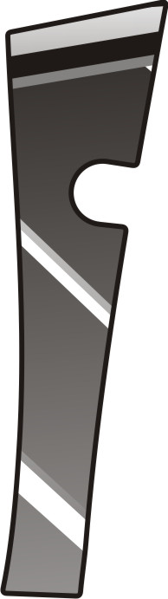 | 517298BL  517298WH  517298OR | Emblem, Side cover, RH.
II
FBG-HDLE TABLE OF LABEL 2012
Label | Drawing | Description
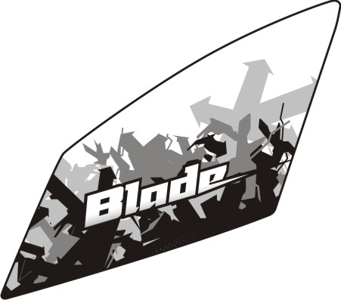 | 517230BL  517230WH  517230OR | Emblem, Front body cover., LH.
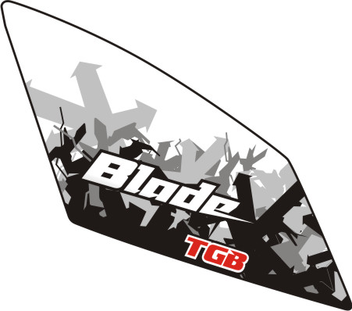 | 517231BL  517231WH  517231OR | Emblem, Front body cover., RH.
 | 516763BL  516763WH  516763OR | Emblem, Fuel tank cover, Upper.
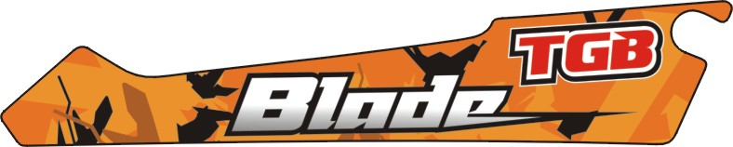 | 516767BL  516767WH  516767OR | Emblem, Fuel tank cover, Upper.
 | 516944 | Emblem, Fuel tank cover, Upper.
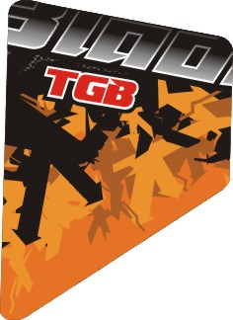 | 516699BL  516699WH  516699OR | Emblem, Rear cover, LH.
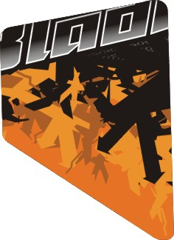 | 516700BL  516700WH  516700OR | Emblem, Rear cover, RH.

I
FBG-HDLE TABLE OF LABEL 2012
Label | Drawing | Description
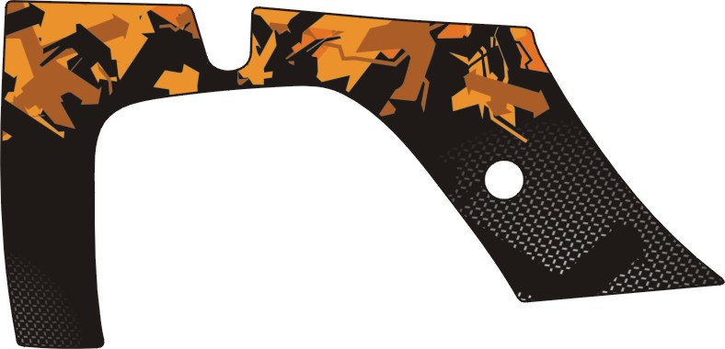 | 516764BL  516764WH  516764OR | Emblem, Side cover, LH.
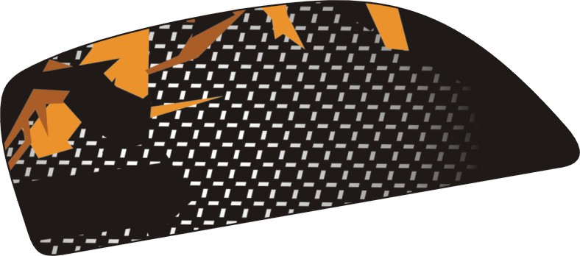 | 516691BL  516691WH  516691OR | Emblem, Side cover,LH.
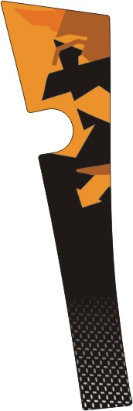 | 516765BL  516765WH  516765OR | Emblem, Side cover, LH.
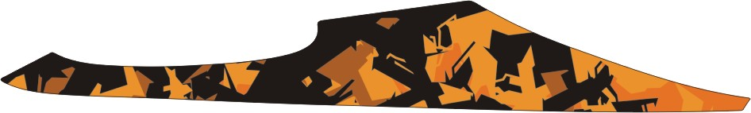 | 516766BL  516766WH  516766OR | Emblem, Side cover, LH.
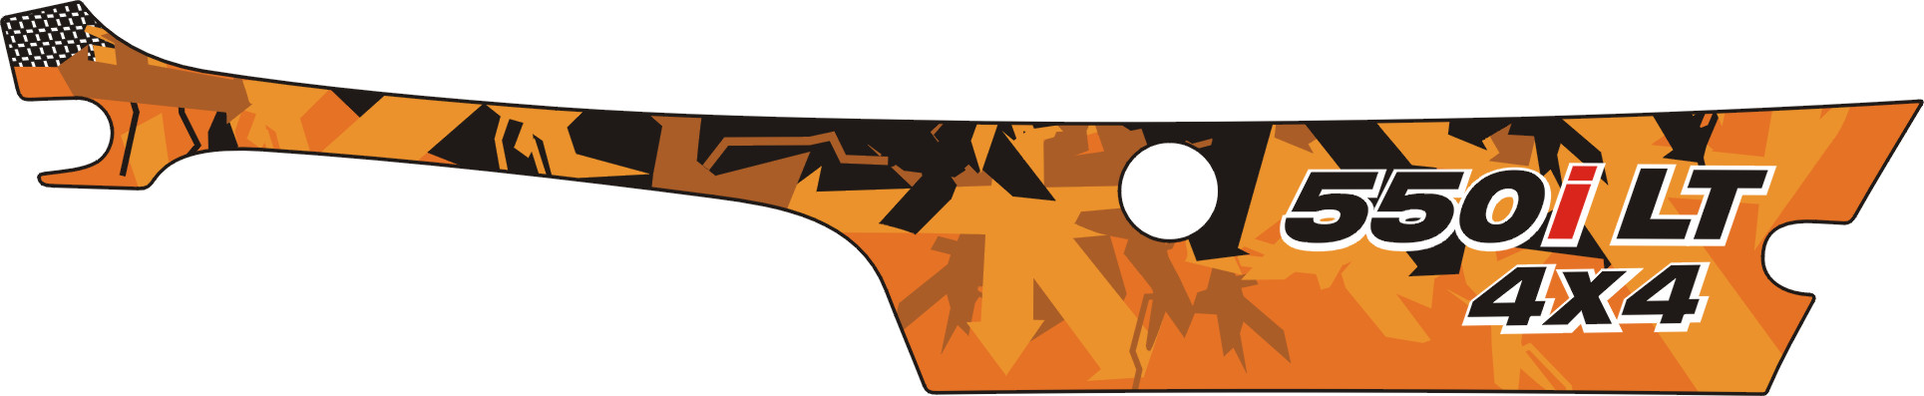 | 517069BL  517069WH  517069OR | Emblem, Side cover, LH.
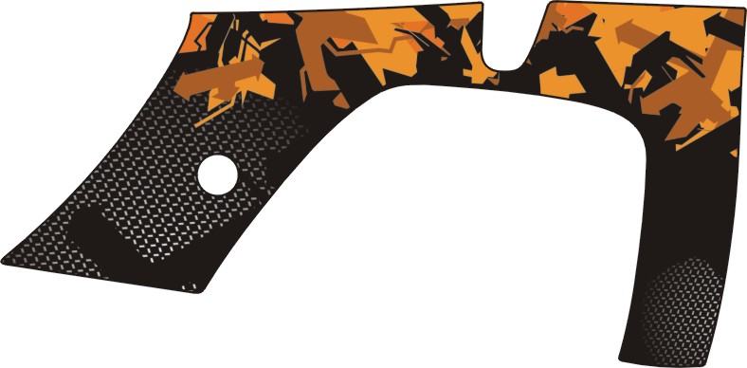 | 516768BL  516768WH  516768OR | Emblem, Side cover, RH.
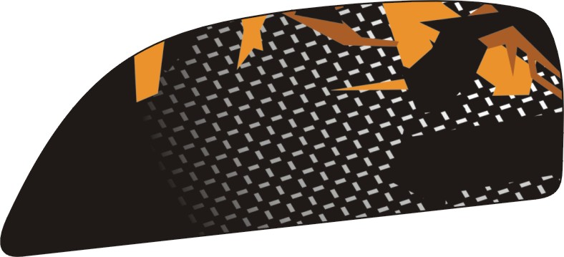 | 516696BL  516696WH  516696OR | Emblem, Side cover, RH.
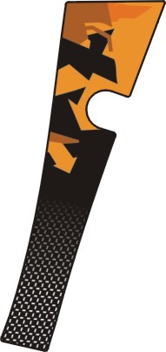 | 516769BL  516769WH  516769OR | Emblem, Side cover, RH.
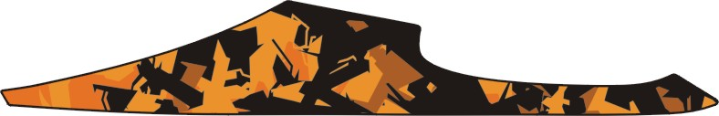 | 516770BL  516770WH  516770OR | Emblem, Side cover, RH.
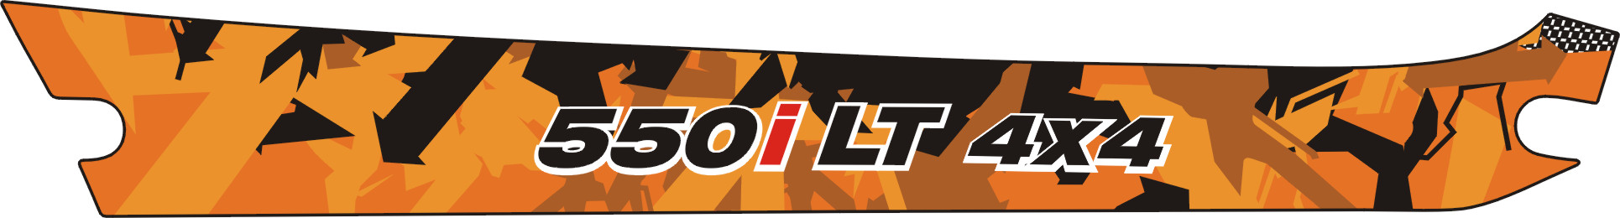 | 517070BL  517070WH  517070OR | Emblem, Side cover, RH.

II

