BK1-B TABLE OF COLORED PART 2011
FOR CZECH (ASP)
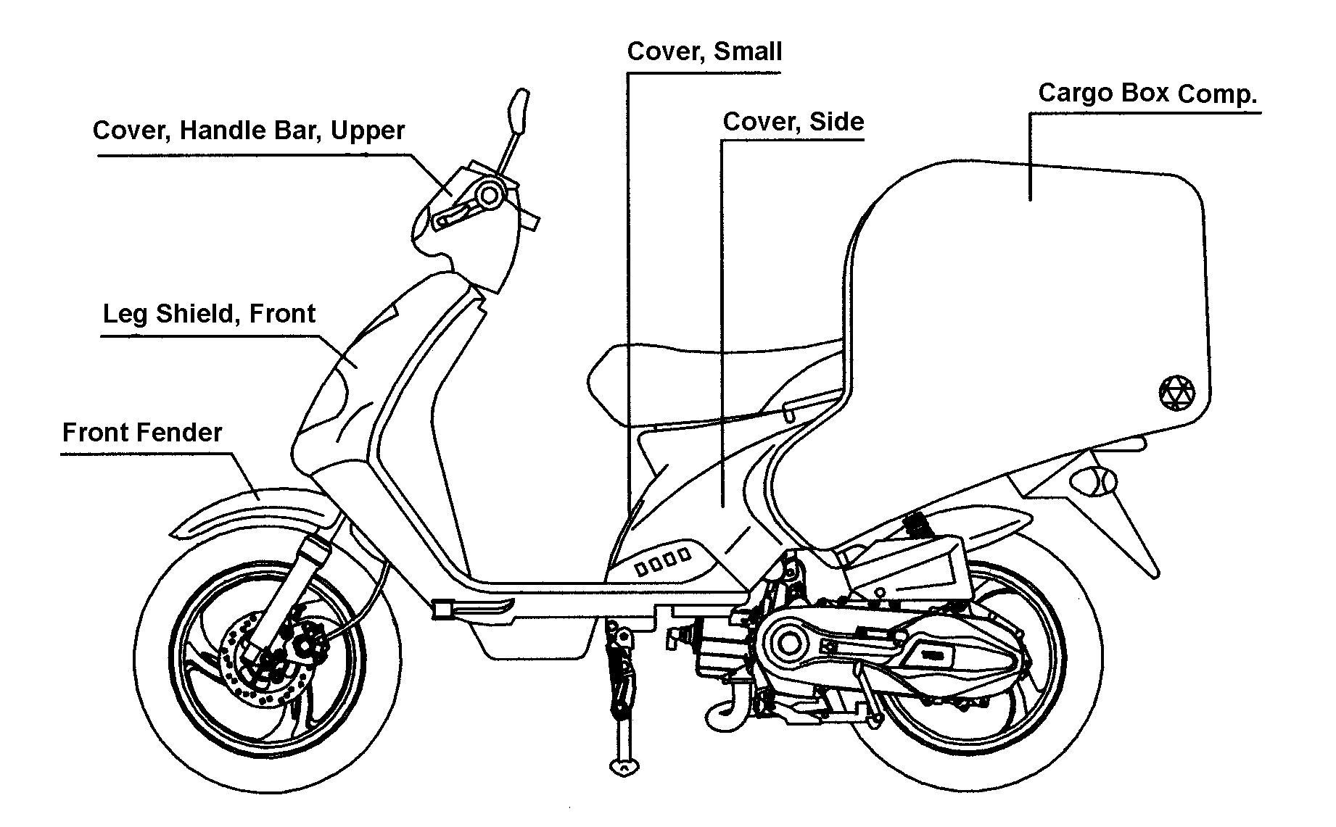
TABLE OF COLORED PART
ITEM  NO. | CODE | A | B | C
ITEM  NO. | Basic Color | Ferrari’s Red | Yellow | Electroplate Blue
ITEM  NO. | Description | FR  Red 701 | YE  Yel 601 | EU  Blu 702
24 | Cover, Side | 453082BFR | 453082BYE | 453082BEU
24 | Cover，Small | BH124PL04FR | BH124PL04YE | BH124PL04EU
 | Cargo Box Comp., With Emblem | 453026CN | 453026CP | 453026CQ
24 | Emblem（Light） | 459784FR | 459784YE | 459784EU
 | Emblem（Right） | 459785FR | 459785YE | 459785EU
 | Emblem（Rear） | 459786FR | 459786YE | 459786EU
 | Leg Shield, Front With Emblem | 401653FRFM | 401653YEFM | 401653EUFM
25 | Leg Shield, Front | 401653FR | 401653YE | 401653EU
 | TGB Emblem | 459777 | 459777 | 459777
28 | Front Fender | 401688FR | 401688YE | 401688EU
31 | Cover, Handle Bar, Upper | 401610FR | 401610YE | 401610EU

Ⅰ
BK1-B TABLE OF LABEL 2011

Label | Drawing | Description
 | 459777 | “TGB” Emblem.
 | 459784 ( FR / YE / EU ) | Emblem, Cargo Box Comp.
 | 459785 ( FR / YE / EU ) | Emblem, Cargo Box Comp.
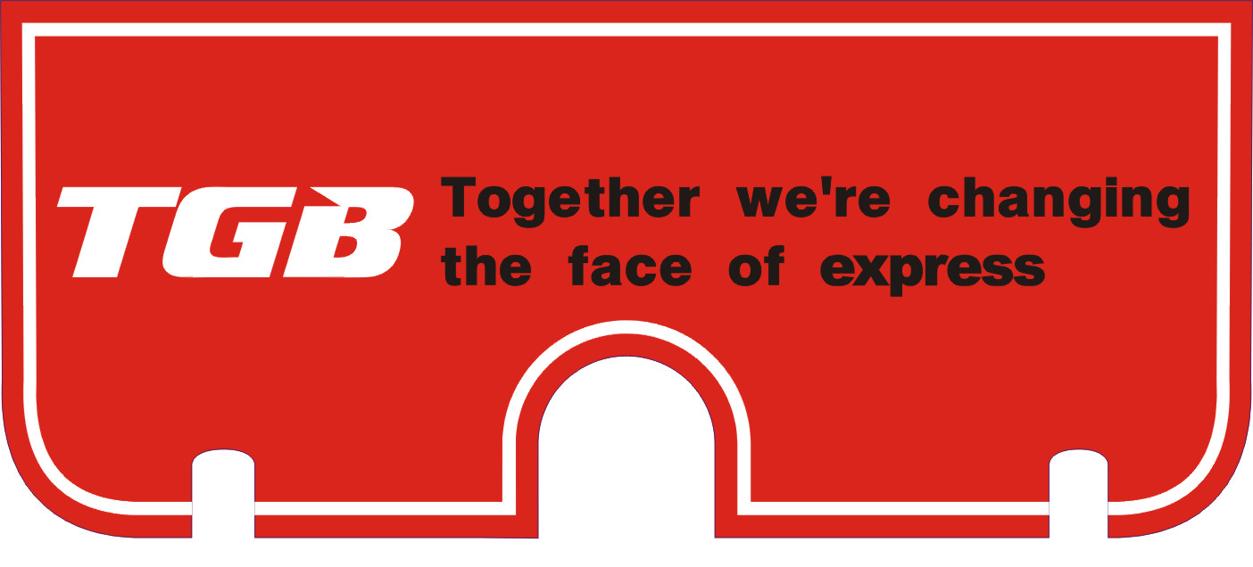 | 459786 ( FR / YE / EU ) | Emblem, Cargo Box Comp.

