BR1 TABLE OF COLORED PART 2010
FOR CZECHOSLOVAKIA
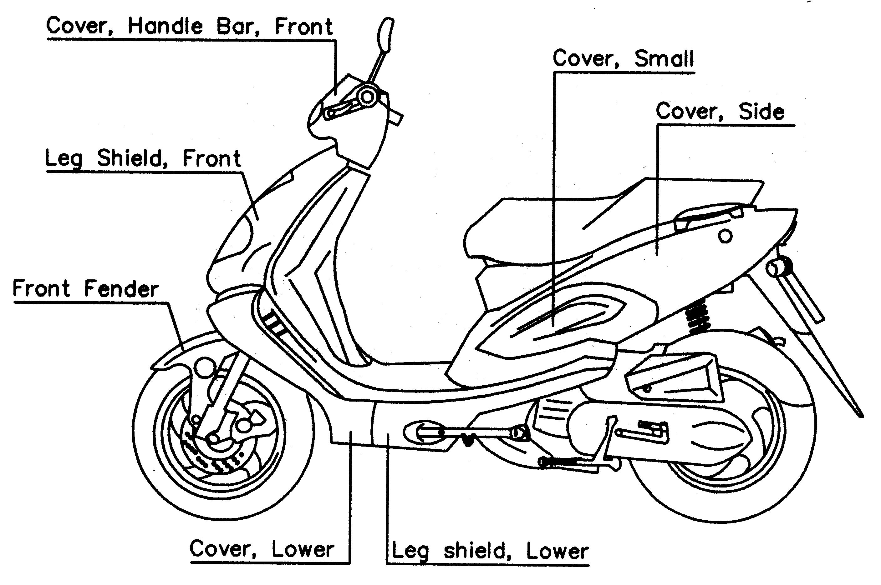
TABLE OF COLORED PART(HAWK)
ITEM  NO. | CODE | A
ITEM  NO. | Basic Color  Description | Pearly Black / Semi-Gloss Black
ITEM  NO. | Basic Color  Description | PA / SE Bla 801 / Bla 605
 | Cover, Side LH., With Emblem | 453001PALAL
 | Cover, Side, LH. | 453001PA
 | Emblem, Side Cover, LH. | 459763SY
 | Cover, Side RH., With Emblem | 453003PARAL
24 | Cover, Side RH. | 453003PA
 | Emblem, Side Cover, RH. | 459764SY
 | Cover, Small, LH. | 453002SE
 | Cover, Small, RH. | 453004SE
 | Leg Shield, Front, With Emblem | 401653PAFZ
 | Leg Shield, Front | 401653PA
25 | Emblem, Leg Shield, Front | 459759SY
 | Emblem, Leg Shield, Front | 459760SY
 | Cover Lower, With Emblem | 455006PABP
 | Cover, Lower | 455006PA
 | Emblem, Cover Lower | 459761
 | Emblem, Cover Lower | 459762
26 | Leg Shield, Lower, With Emblem | 455005SYDM
 | Leg Shield, Lower | 455005SY
 | Emblem, Leg Shield, Lower | 459749PA
 | Emblem, Leg Shield, Lower | 459750PA
 | Front Fender, With Emblem | 456003PAF5
28 | Front Fender | 456003PA
 | Emblem, Front Fender | 459744
29 | RIM COMP., FRONT | 412933YSE
31 | Cover, Handle Bar, Upper | 401610PA
34 | RIM COMP., REAR | 413406YSE
Ⅰ
BR1 TABLE OF COLORED PART 2009
FOR CZECHOSLOVAKIA
TABLE OF COLORED PART(Hawk 18)
ITEM  NO. | CODE | A
ITEM  NO. | Basic Color  Description | Pearly Black
ITEM  NO. | Basic Color  Description | PA  Bla 801
 | Cover, Side LH., With Emblem | 453001PALAH
 | Cover, Side, LH. | 453001PA
 | Emblem, Side Cover, LH. | 459359
 | Emblem, Side Cover, LH. | 459360
 | Emblem Side Cover, LH. | 459361
 | Emblem, Side Cover, LH. | 459363
 | Cover, Side RH., With Emblem | 453003PARAH
 | Cover, Side RH. | 453003PA
 | Emblem, Side Cover, RH. | 459359
24 | Emblem, Side Cover, RH. | 459360
 | Emblem, Side Cover, RH. | 459361
 | Emblem, Side Cover, RH. | 459363
 | Cover, Small, LH., With Emblem | 453002PAL3
 | Cover, Small, LH. | 453002PA
 | Emblem, Cover, Small, LH. | 459259
 | Cover, Small, RH., With Emblem | 453004PAR3
 | Cover, Small, RH. | 453004PA
 | Emblem, Cover, Small, RH. | 459261
 | Emblem | ※459362
 | Leg Shield, Front, With Emblem | 401653PAFV
 | Leg Shield, Front | 401653PA
 | Emblem, Leg Shield, Front | 459352
25 | Emblem, Leg Shield, Front | 459354
 | Emblem, Leg Shield, Front | 459355
 | Emblem, Leg Shield, Front | 459605
 | Emblem, Leg Shield, Front | 459606
 | “ TGB ” Emblem | 459341
 | Cover Lower, With Emblem | 455006PABF
 | Cover, Lower | 455006PA
 | Emblem, Cover Lower | 459366
26 | Leg Shield, Lower, With Emblem | 455005PAD7
 | Leg Shield, Lower | 455005PA
 | Emblem, Leg Shield, Lower | 459356
 | Emblem, Leg Shield, Lower | 459357
27 | Front Fork, With Emblem | 402116B
 | Emblem, Front Fork | 459104
 | Front Fender, With Emblem | 456003PAF1
28 | Front Fender | 456003PA
 | Emblem, Front Fender | 459358
29 | RIM COMP., FRONT | 412933PAY
 | Cover, Handle Bar, Upper, With Emblem | 401610PAF2
31 | Cover, Handle Bar, Upper | 401610PA
 | Emblem, Cover, Handle Bar, Upper | 459358
 | Emblem, Cover, Handle Bar, Upper | 459367
34 | RIM COMP., REAR | 413406PAY
Ⅰ

BR1 TABLE OF COLORED PART 2009
FOR CZECHOSLOVAKIA
TABLE OF COLORED PART(Hawk 42)
ITEM  NO. | CODE | A
ITEM  NO. | Basic Color  Description | Ferrari’s Red
ITEM  NO. | Basic Color  Description | FR Red 701
 | Cover, Side LH., With Emblem | 453001FRLAA
 | Cover, Side, LH. | 453001FR
 | Emblem, Side Cover, LH. | 459607
 | Cover, Side RH., With Emblem | 453003FRRAA
 | Cover, Side RH. | 453003FR
24 | Emblem, Side Cover, RH. | 459608
 | Cover, Small, LH., With Emblem | 453002PAL3
 | Cover, Small, LH. | 453002PA
 | Emblem, Cover, Small, LH. | 459259
 | Cover, Small, RH., With Emblem | 453004PAR3
 | Cover, Small, RH. | 453004PA
 | Emblem, Cover, Small, RH. | 459261
 | Leg Shield, Front, With Emblem | 401653FRFV
 | Leg Shield, Front | 401653FR
 | Emblem, Leg Shield, Front | 459352
 | Emblem, Leg Shield, Front | 459354
25 | Emblem, Leg Shield, Front | 459355
 | Emblem, Leg Shield, Front | 459605
 | Emblem, Leg Shield, Front | 459606
 | “ TGB ” Emblem | 459341
 | Cover Lower, With Emblem | 455006FRBI
 | Cover, Lower | 455006FR
 | Emblem, Cover Lower | 459444
 | Emblem, Cover Lower | 459445
26 | Leg Shield, Lower, With Emblem | 455005PADD
 | Leg Shield, Lower | 455005PA
 | Emblem, Leg Shield, Lower | 459449
 | Emblem | ※459446
 | Emblem | ※459447
27 | Front Fork, With Emblem | 402116B
 | Emblem, Front Fork | 459104
 | Front Fender, With Emblem | 456003FRF1
28 | Front Fender | 456003FR
 | Emblem, Front Fender | 459358
29 | RIM COMP., FRONT | 412933PAY
 | Cover, Handle Bar, Upper, With Emblem | 401610FRF2
31 | Cover, Handle Bar, Upper | 401610FR
 | Emblem, Cover, Handle Bar, Upper | 459358
 | Emblem, Cover, Handle Bar, Upper | 459367
34 | RIM COMP., REAR | 413406PAY
Ⅰ

BR1 TABLE OF COLORED PART FOR CZECHOSLOVAKIA
TABLE OF COLORED PART（Hawk）
ITEM  NO. | CODE | A
ITEM  NO. | Basic Color  Description | Peary Black
ITEM  NO. | Basic Color  Description | PA  Bla 801
 | Cover, Side LH., With Emblem | 453001PALA1
 | Cover, Side, LH. | 453001PA
 | Emblem, Side Cover, LH. | 459359
 | Emblem, Side Cover, LH. | 459360
 | Emblem Side Cover, LH. | 459361
 | Emblem, Side Cover, LH. | 459363
 | Emblem, Side Cover, LH. | 459364
 | Emblem Side Cover, LH. | 459365
 | Cover, Side RH., With Emblem | 453003PARA1
 | Cover, Side RH. | 453003PA
 | Emblem, Side Cover, RH. | 459359
24 | Emblem, Side Cover, RH. | 459360
 | Emblem, Side Cover, RH. | 459361
 | Emblem, Side Cover, RH. | 459363
 | Emblem, Side Cover, RH. | 459364
 | Emblem, Side Cover, RH. | 459365
 | Emblem, Side Cover | 459362
 | Cover, Small, LH., With Emblem | 453002PAL3
 | Cover, Small, LH. | 453002PA
 | Emblem, Cover, Small, LH. | 459259
 | Cover, Small, RH., With Emblem | 453004PAR3
 | Cover, Small, RH. | 453004PA
 | Emblem, Cover, Small, RH. | 459261
 | Leg Shield, Front, With Emblem | 401653PAFL
 | Leg Shield, Front | 401653PA
 | Emblem, Leg Shield, Front | 459605
 | Emblem, Leg Shield, Front | 459351
 | Emblem, Leg Shield, Front | 459352
25 | Emblem, Leg Shield, Front | 459606
 | Emblem, Leg Shield, Front | 459354
 | Emblem, Leg Shield, Front | 459355
 | “ TGB ” Emblem | 459341
 | Cover Lower, With Emblem | 455006PABF
 | Cover, Lower | 455006PA
 | Emblem, Cover Lower | 459366
26 | Leg Shield, Lower, With Emblem | 455005PAD7
 | Leg Shield, Lower | 455005PA
 | Emblem, Leg Shield, Lower | 459356
 | Emblem, Leg Shield, Lower | 459357
27 | Front Fork, With Emblem | 402116B
 | Emblem, Front Fork | 459104
 | Front Fender, With Emblem | 456003PAF1
28 | Front Fender | 456003PA
 | Emblem, Front Fender | 459358
 | Cover, Handle Bar, Upper, With Emblem | 401610PAF2
31 | Cover, Handle Bar, Upper | 401610PA
 | Emblem, Cover, Handle Bar, Upper | 459358
 | Emblem, Cover, Handle Bar, Upper | 459367
Ⅰ
BR1 TABLE OF COLORED PART FOR CZECHOSLOVAKIA
TABLE OF COLORED PART（DOUBLE XX）
ITEM  NO. | CODE | A
ITEM  NO. | Basic Color  Description | Electroplate Blue
ITEM  NO. | Basic Color  Description | EU Blu 702
 | Cover, Side LH., With Emblem | 453001EULZ
 | Cover, Side, LH. | 453001EU
 | Emblem, Side Cover, LH. | 459343
 | Emblem, Side Cover, LH. | 459344
 | Emblem Side Cover, LH. | 459220FR
 | Cover, Side RH., With Emblem | 453003EURZ
 | Cover, Side RH. | 453003EU
 | Emblem, Side Cover, RH. | 459343
24 | Emblem, Side Cover, RH. | 459344
 | Emblem, Side Cover, RH. | 459220FR
 | Emblem, Side Cover | 459345
 | Cover, Small, LH., With Emblem | 453002SWL3
 | Cover, Small, LH. | 453002SW
 | Emblem, Cover, Small, LH. | 459259
 | Cover, Small, RH., With Emblem | 453004SWR3
 | Cover, Small, RH. | 453004SW
 | Emblem, Cover, Small, RH. | 459261
 | Leg Shield, Front, With Emblem | 401653EUFK
 | Leg Shield, Front | 401653EU
 | Emblem, Leg Shield, Front | 459336
 | Emblem, Leg Shield, Front | 459337
25 | Emblem, Leg Shield, Front | 459338
 | Emblem, Leg Shield, Front | 459339
 | Emblem, Leg Shield, Front | 459340
 | “ TGB ” Emblem | 459341
 | Cover, Lower | 455006EU
26 | Leg Shield, Lower, With Emblem | 455005EUD6
 | Leg Shield, Lower | 455005EU
 | Emblem, Leg Shield, Lower | 459342
27 | Front Fork, With Emblem | 402116D
 | Emblem, Front Fork | 459349
 | Front Fender, With Emblem | 456003EUF2
28 | Front Fender | 456003EU
 | Emblem, Front Fender | 459348
 | Cover, Handle Bar, Upper, With Emblem | 401610EUF1
31 | Cover, Handle Bar, Upper | 401610EU
 | Emblem, Cover, Handle Bar, Upper | 459346
 | Emblem, Cover, Handle Bar, Upper | 459347
Ⅰ
BR1 TABLE OF LABEL(HAWK) 2010
Label | Drawing | Description
 | 459763SY | Emblem, Side Cover, LH.
 | 459764SY | Emblem, Side Cover, RH.
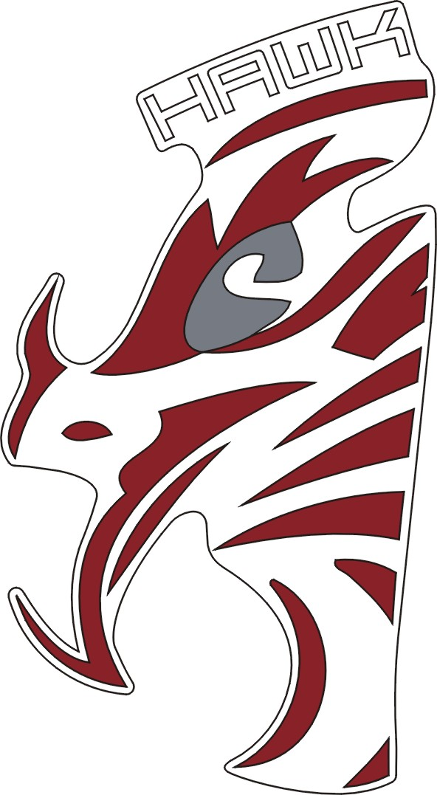 | 459759SY | Emblem, Leg Shield, Front
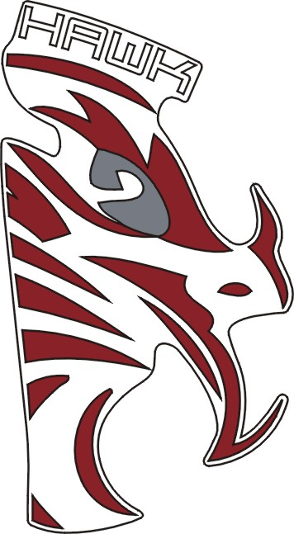 | 459760SY | Emblem, Leg Shield, Front
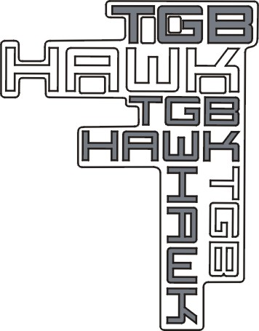 | 459761 | Emblem, Cover Lower
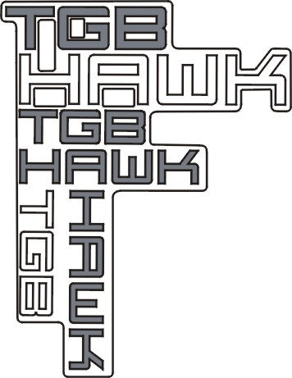 | 459762 | Emblem, Cover Lower

BR1 TABLE OF LABEL(HAWK) 2010
Label | Drawing | Description
 | 459749PA | Emblem, eg Shield, Lower
 | 459750PA | Emblem, Leg Shield, Lower
 | 459744 | Emblem, Front Fender

