VSG-DE TABLE OF COLORED PART 2011

TABLE OF COLORED PART (550EFi iRS)
ITEM | CODE | A | B | C
NO. | Basic Color | White | Yellow | Black
 | Description | WH | YE | BL
 | FRONT BODY COVER, With Emblem | 512463EWHF7 | 512463EYEF8 | 512463EBLF9
 | FRONT BODY COVER | 512463EWH | 512463EYE | 512463EBL
 | Emblem | 516961WH | 516961YE | 516961BL
 | Emblem | 516962WH | 516962YE | 516962BL
 | Emblem | 516963WH | 516963YE | 516963BL
B20 | Emblem | 516964WH | 516964YE | 516964BL
 | Emblem | 516965WH | 516965YE | 516965BL
 | Emblem | 516966WH | 516966YE | 516966BL
 | ORNAMENTAL, FRONT COVER, With Emblem | 512445BLF1 | 512445BLF1 | 512445BLF1
 | ORNAMENTAL, FRONT COVER | 512445BL | 512445BL | 512445BL
 | Emblem | 516644 | 516644 | 516644
 | COVER SIDE, LH., With Emblem | 512529BLL4 | 512529BLL4 | 512529BLL4
 | COVER SIDE, LH. | 512529BL | 512529BL | 512529BL
B21 | Emblem | 515687 | 515687 | 515687
 | COVER SIDE, RH., With Emblem | 512530ABLR4 | 512530ABLR4 | 512530ABLR4
 | COVER SIDE, RH. | 512530ABL | 512530ABL | 512530ABL
 | Emblem | 515688 | 515688 | 515688
 | REAR BODY COVER COMP., With Emblem | 514426HWHRJ | 514426HYERK | 514426HBLRL
 | REAR BODY COVER COMP. | 514426HWH | 514426HYE | 514426HBL
 | Emblem | 517141WH | 517141YE | 517141BL
B22 | Emblem | 517142WH | 517142YE | 517142BL
 | Emblem | 516969WH | 516969YE | 516969BL
 | Emblem | 516970WH | 516970YE | 516970BL
 | ORNAMENTAL, CARRIER TAIL | 515098WH | 515098YE | 515098BL

Ⅰ
VSG-DE TABLE OF LABEL 2011
Label | Drawing | Description
 | 516961WH  516961BL  516961YE | FRONT BODY COVER
 | 516962WH  516962BL  516962YE | FRONT BODY COVER
 | 516963WH  516963BL  516963YE | FRONT BODY COVER
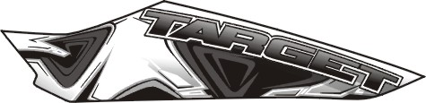 | 516964WH  516964BL  516964YE | FRONT BODY COVER
 | 516965WH  516965BL  516965YE | FRONT BODY COVER
 | 516966WH  516966BL  516966YE | FRONT BODY COVER
 | 517141WH  517141BL  517141YE | REAR BODY COVER COMP.
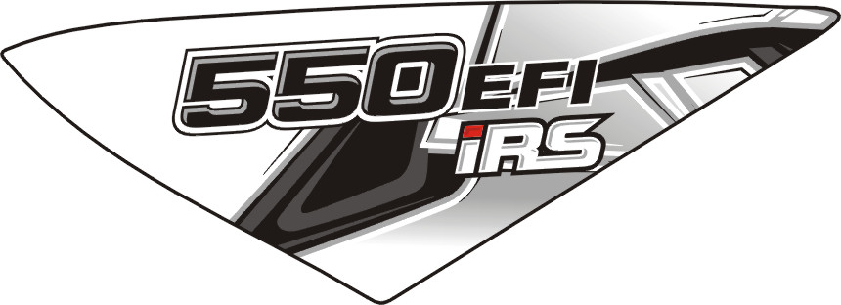 | 517142WH  517142BL  517142YE | REAR BODY COVER COMP.

I
VSG-DE TABLE OF LABEL 2011
Label | Drawing | Description
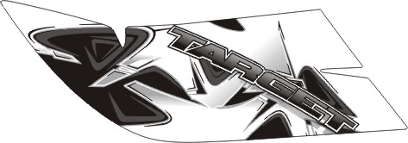 | 516969WH  516969BL  516969YE | REAR BODY COVER COMP.
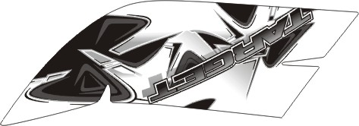 | 516970WH  516970BL  516970YE | REAR BODY COVER COMP.
 | 516644 | ORNAMENTAL, FRONT COVER.
 | 515687 | COVER SIDE, LH.
 | 515688 | COVER SIDE, RH.

II

