BH1-F TABLE OF COLORED PART 2009

TABLE OF COLORED PART (FASHION)
ITEM  NO. | CODE | A | B
ITEM  NO. | Basic Color  Description | Pearly Blue | Shell White
ITEM  NO. | Basic Color  Description | PL Blu 707 | SH Whi 702
 | Cover , Side With Emblem | 453080PLL1 | 453080SHL2
 | Cover , Side | 453080PL | 453080SH
 | Emblem | 459809 | 459803
24 | Emblem | 459810 | 459804
 | Cover , Small | BH124PL04PL | BH124PL04SH
 | Cover , Tail Lamp | BH124PL03SE | BH124PL03SE
 | Leg Shield , Front With Emblem | 454022APLF7 | 454022ASHF8
25 | Leg Shield , Front | 454022APL | 454022ASH
 | Emblem | 459807 | 459801
 | Emblem | 459808 | 459802
 | Front Fork, With Emblem | 412720SEA | 412720SEA
27 | Front Fork | 412720SE | 412720SE
 | Emblem | 459806 | 459806
28 | Front Fender | BH128PL01SE | BH128PL01SE
 | Rim Comp., Front, With Emblem | 412933YMYF1 | 412933YMYF1
29 | Rim Comp., Front | 412933YMY | 412933YMY
 | Emblem | 459800 | 459800
 | Emblem | 459812 | 459812
 | Cover , Handle Bar , Upper, With Emblem | 457001PLF1 | 457001SHF2
31 | Cover , Handle Bar , Upper | 457001PL | 457001SH
 | Emblem | 459811 | 459805
 | Rim Comp., Rear, With Emblem | 413406YMYR1 | 413406YMYR1
34 | Rim Comp., Rear | 413406YMY | 413406YMY
 | Emblem | 459800 | 459800
 | Emblem | 459812 | 459812
Ⅰ

BH1-F TABLE OF COLORED PART 2009

TABLE OF COLORED PART (SPORTING)
ITEM  NO. | CODE | A
ITEM  NO. | Basic Color  Description | Warship Gary
ITEM  NO. | Basic Color  Description | WG Gra 705
 | Cover , Side With Emblem | 453080WGL3
 | Cover , Side | 453080WG
 | Emblem | 459796
24 | Emblem | 459797
 | Cover , Small | BH124PL04WG
 | Cover , Tail Lamp | BH124PL03SE
 | Leg Shield , Front With Emblem | 454022AWGF9
25 | Leg Shield , Front | 454022AWG
 | Emblem | 459794
 | Emblem | 459795
 | Front Fork, With Emblem | 412720SEB
27 | Front Fork | 412720SE
 | Emblem | 459799
28 | Front Fender | BH128PL01SE
 | Rim Comp., Front, With Emblem | 412933YMYF1
29 | Rim Comp., Front | 412933YMY
 | Emblem | 459800
 | Emblem | 459812
 | Cover , Handle Bar , Upper, With Emblem | 457001WGF3
31 | Cover , Handle Bar , Upper | 457001WG
 | Emblem | 459798
 | Rim Comp., Rear, With Emblem | 413406YMYR1
34 | Rim Comp., Rear | 413406YMY
 | Emblem | 459800
 | Emblem | 459812
Ⅰ

BH1-F TABLE OF LABEL

Label | Drawing | Description
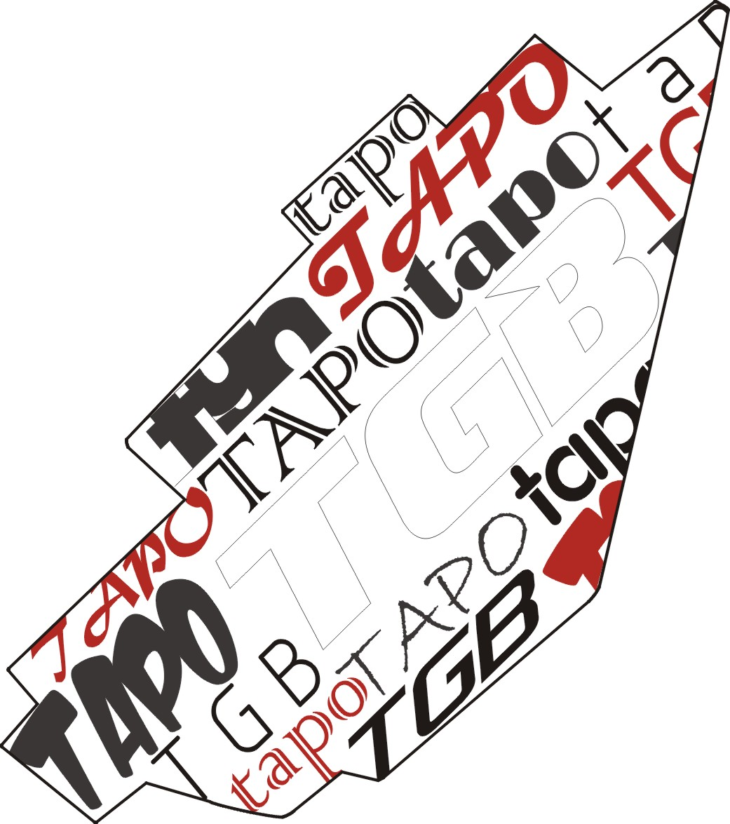 | 459794 | Emblem, Leg Shield , Front., LH.
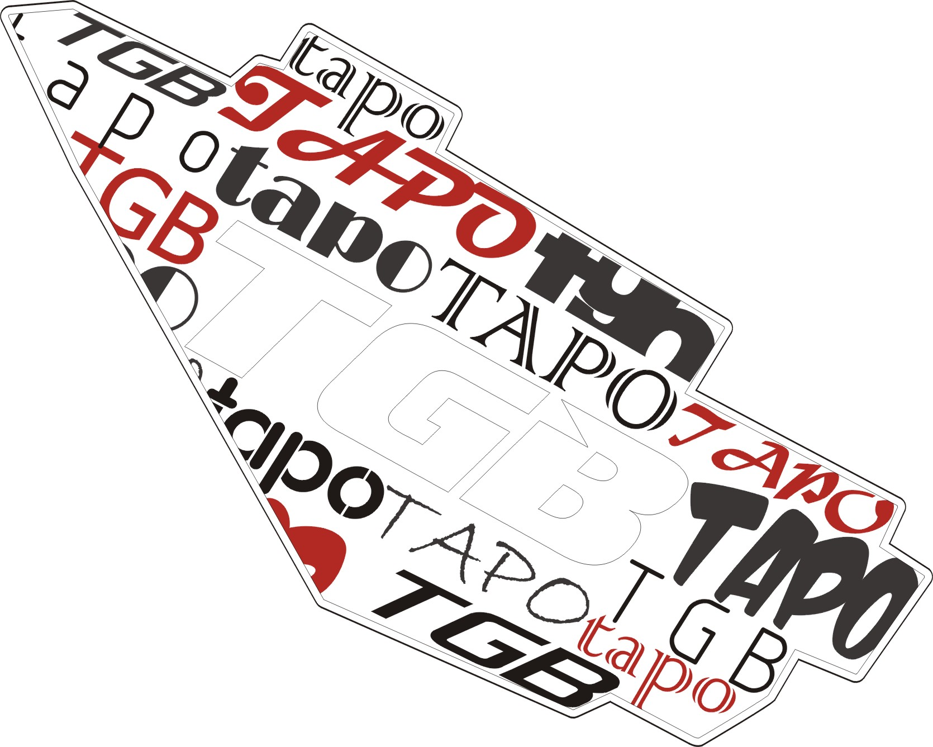 | 459795 | Emblem, Leg Shield , Front., RH.
 | 459796 | Emblem, Cover , Side., LH.
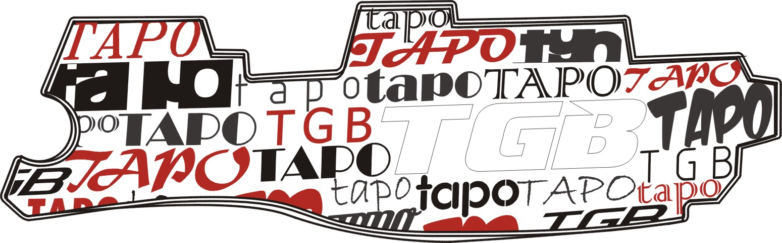 | 459797 | Emblem, Cover , Side., RH.
 | 459798 | Emblem, Cover , Handle Bar , Upper
 | 459799 | Emblem, Front Fork
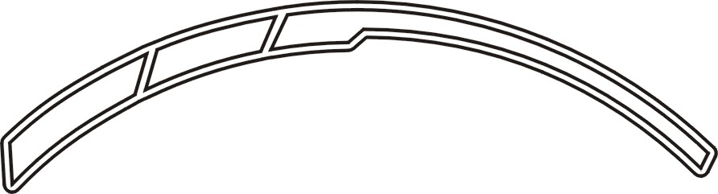 | 459800 | Emblem, Rim Comp., LH.
 | 459801 | Emblem, Leg Shield , Front., LH.
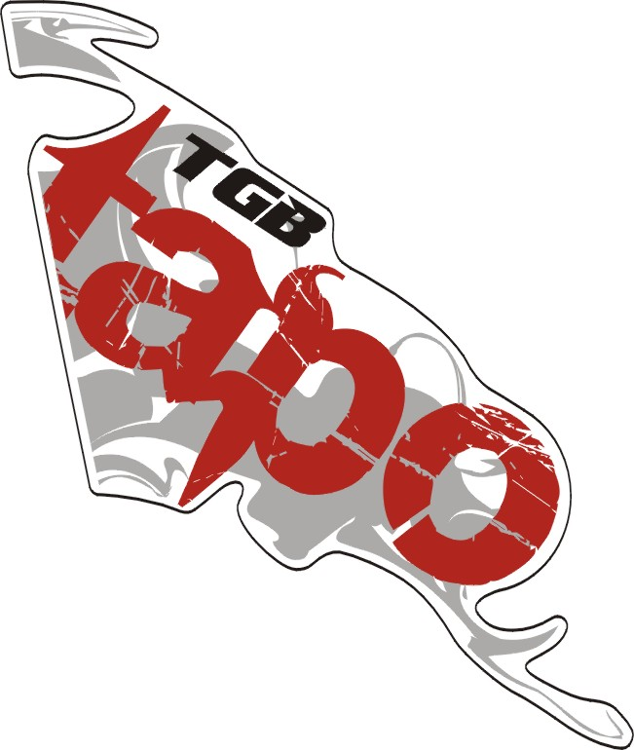 | 459802 | Emblem, Leg Shield , Front., RH.

BH1-F TABLE OF LABEL

Label | Drawing | Description
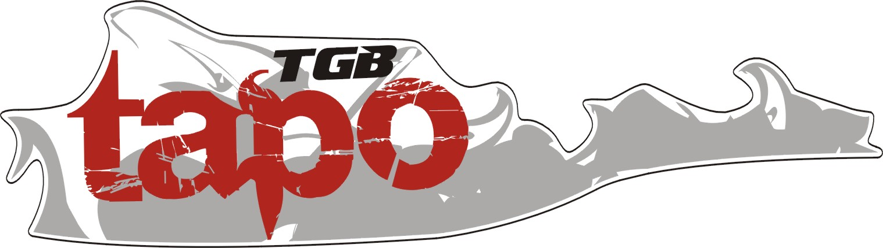 | 459803 | Emblem, Cover , Side., LH.
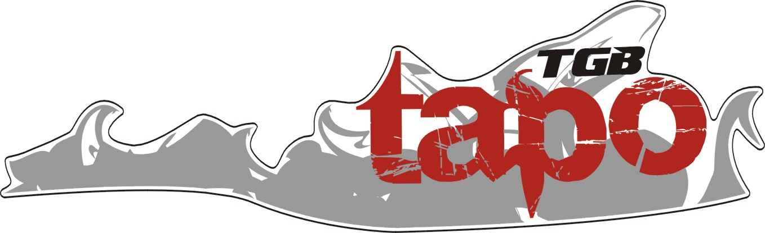 | 459804 | Emblem, Cover , Side., RH.
 | 459805 | Emblem, Cover , Handle Bar , Upper
 | 459806 | Emblem, Front Fork
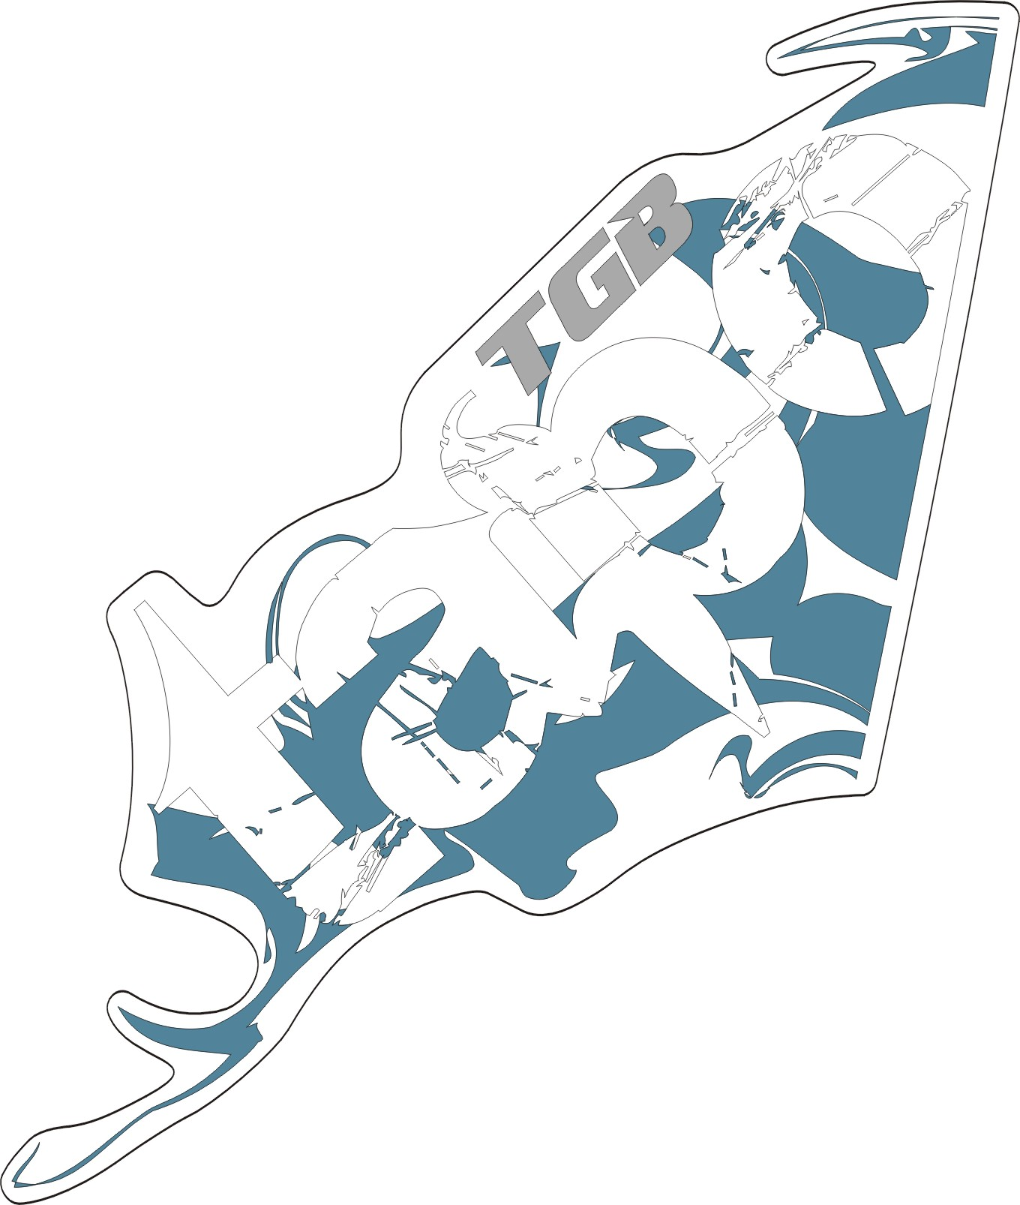 | 459807 | Emblem, Leg Shield , Front., LH.
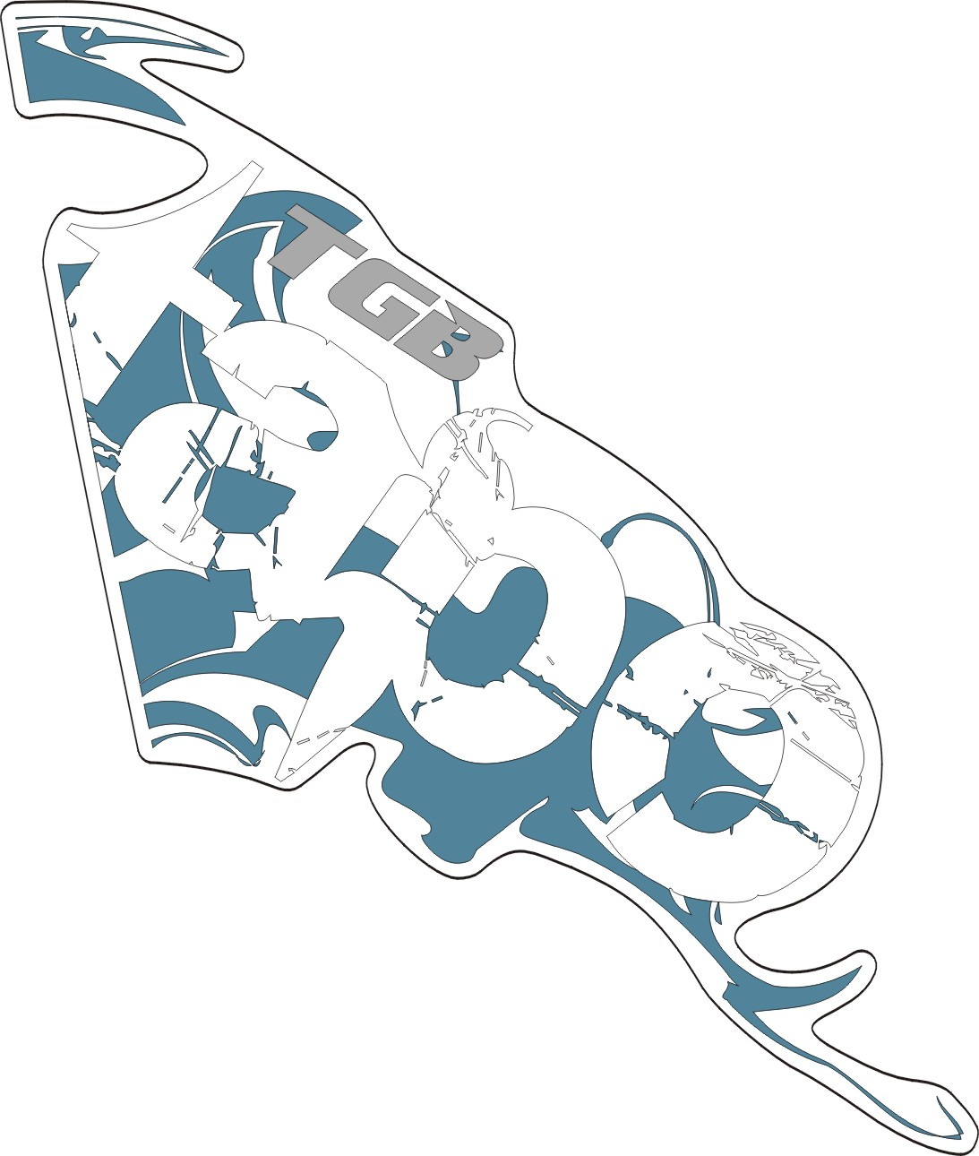 | 459808 | Emblem, Leg Shield , Front., RH.
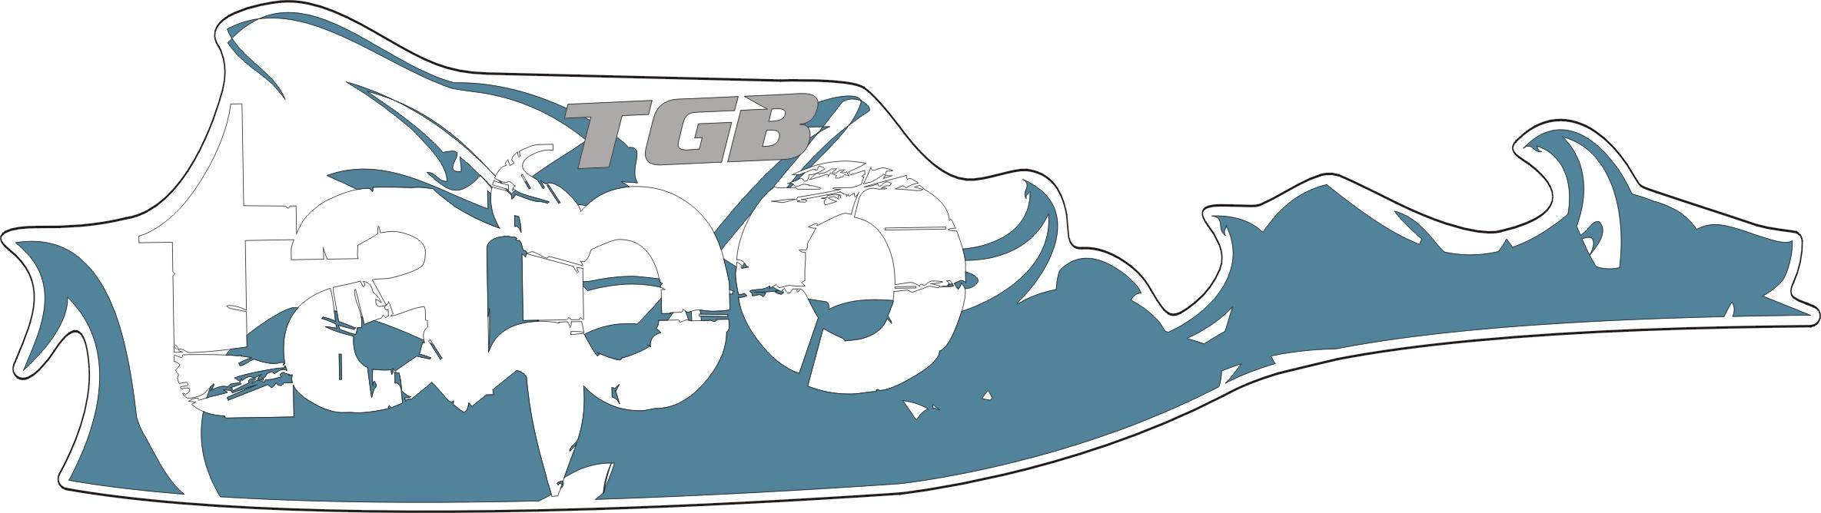 | 459809 | Emblem, Cover , Side., LH.
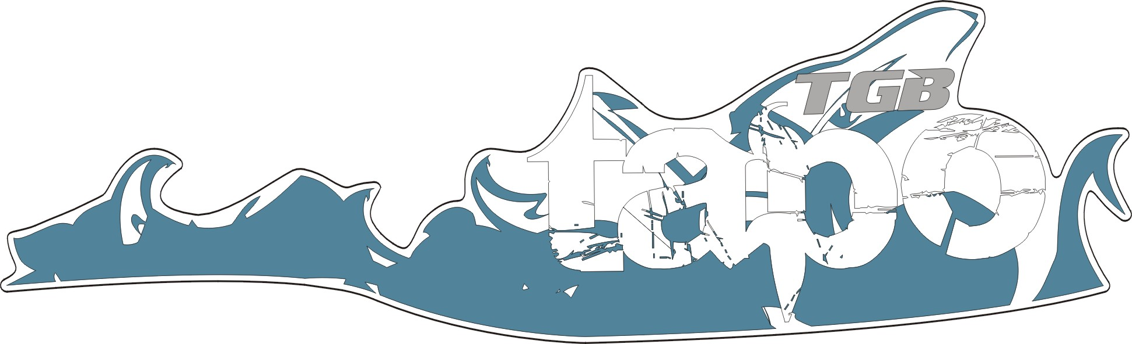 | 459810 | Emblem, Cover , Side., RH.
 | 459811 | Emblem, Cover , Handle Bar , Upper
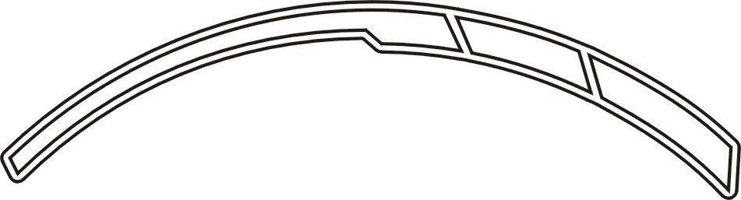 | 459812 | Emblem, Rim Comp., RH.

