VSG-D TABLE OF COLORED PART 2010

TABLE OF COLORED PART(550IRS)
ITEM | CODE | A | B
NO. | Basic Color | Black | White
 | Description | BL | WH
 | FRONT BODY COVER, With Emblem | 512463HBLF8 | 512463HWHF9
 | FRONT BODY COVER | 512463HBL | 512463HWH
 | Emblem | 516729BL | 516729WH
 | Emblem | 516730BL | 516730WH
B20 | Emblem | 516731BL | 516731WH
 | Emblem | 516732BL | 516732WH
 | Emblem | 516733BL | 516733WH
 | Emblem | 516734BL | 516734WH
 | ORNAMENTAL, FRONT COVER | 512445C | 512445C
 | COVER SIDE, LH. | 512529CL1 | 512529CL1
 | COVER SIDE, LH., With Emblem | 512529C | 512529C
B21 | Emblem | 515687 | 515687
 | COVER SIDE, RH., With Emblem | 512530CAR1 | 512530CAR1
 | COVER SIDE, RH. | 512530CA | 512530CA
 | Emblem | 515688 | 515688
 | REAR BODY COVER COMP., With Emblem | 514426ABLRF | 514426AWHRG
 | REAR BODY COVER COMP. | 514426ABL | 514426AWH
 | Emblem | 516737BL | 516737WH
B22 | Emblem | 516738BL | 516738WH
 | Emblem | 516735BL | 516735WH
 | Emblem | 516736BL | 516736WH
 | ORNAMENTAL, CARRIER TAIL | 515098BL | 515098WH
Ⅰ

VSG-D TABLE OF LABEL
Label | Drawing | Description
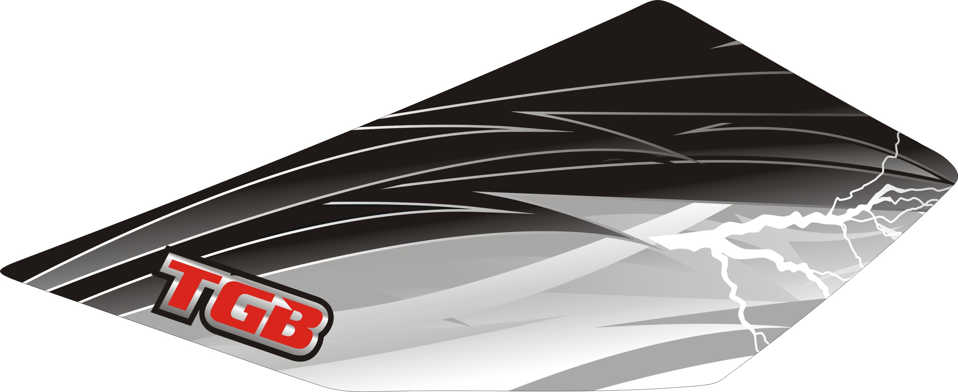 | 516729BL  516729WH | FRONT BODY COVER  702,-
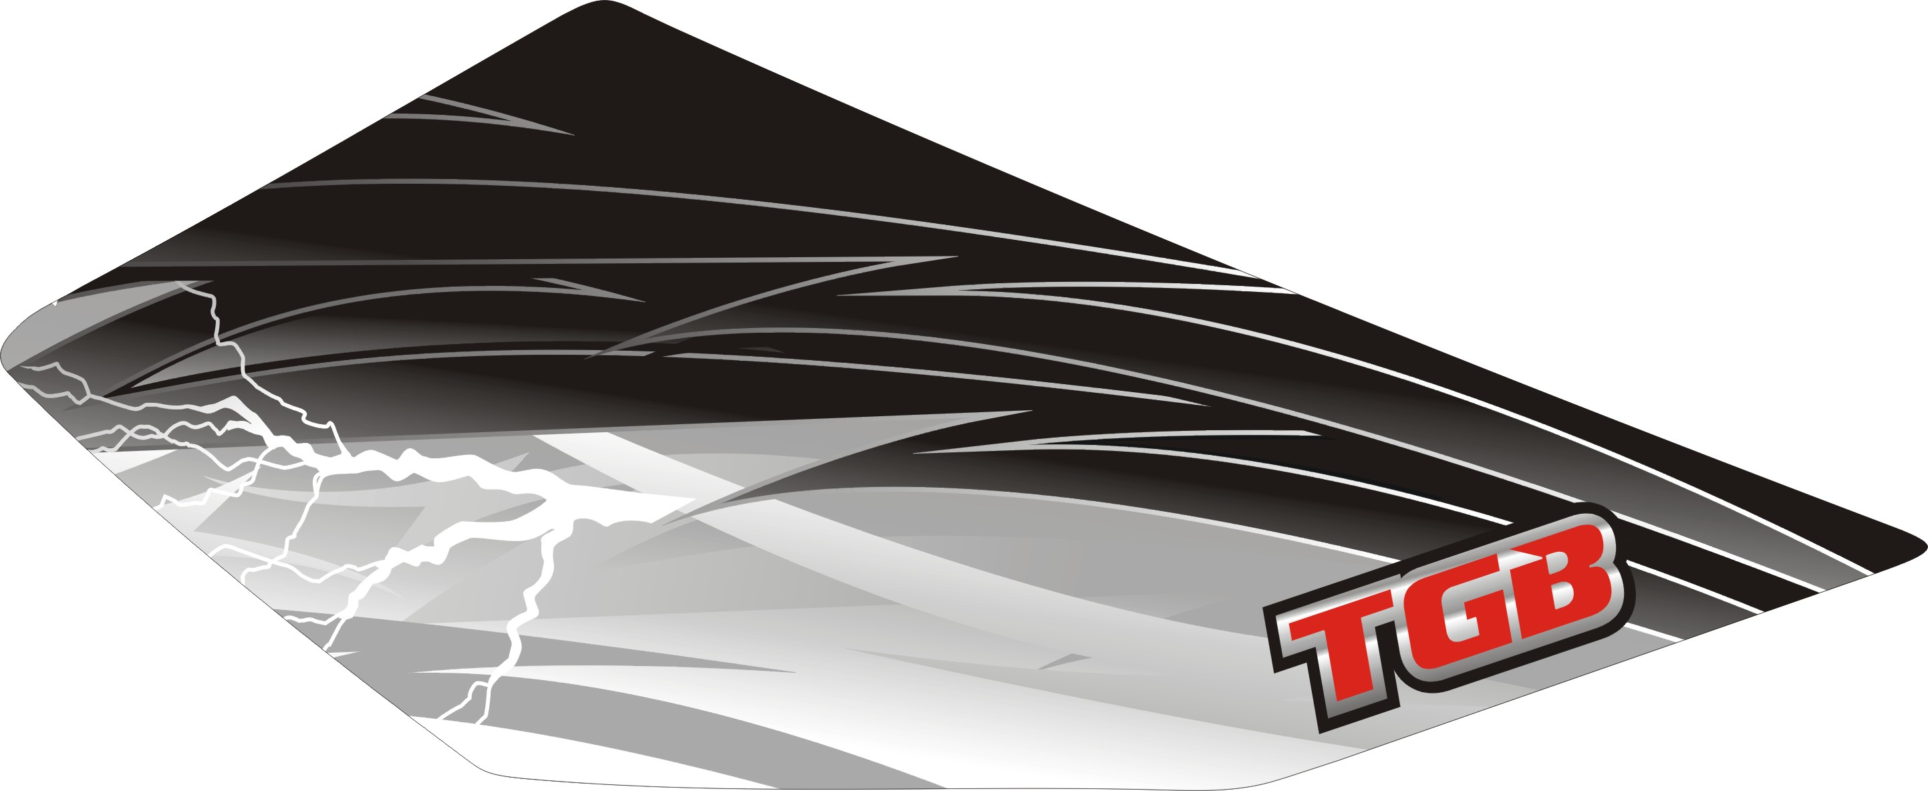 | 516730BL  516730WH | FRONT BODY COVER  702,-
 | 516731BL  516731WH | FRONT BODY COVER  702,-
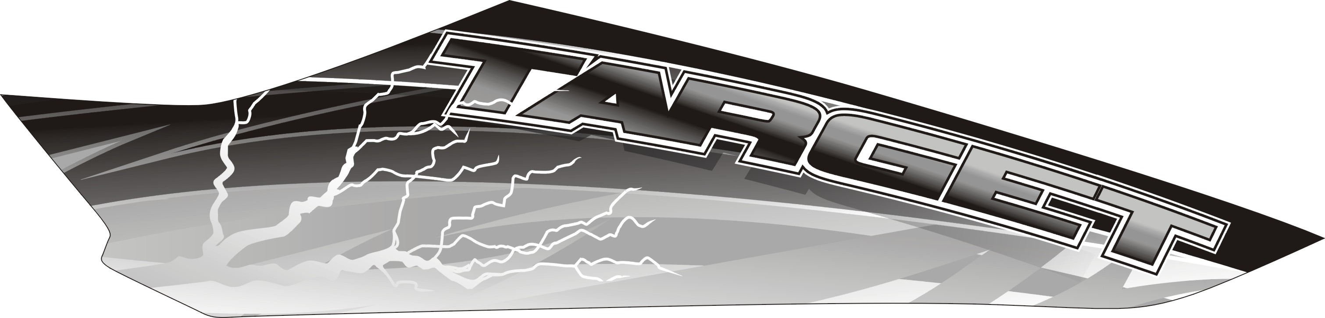 | 516732BL  516732WH | FRONT BODY COVER  702,-
 | 516733BL  516733WH | FRONT BODY COVER  702,-
 | 516734BL  516734WH | FRONT BODY COVER  702,-
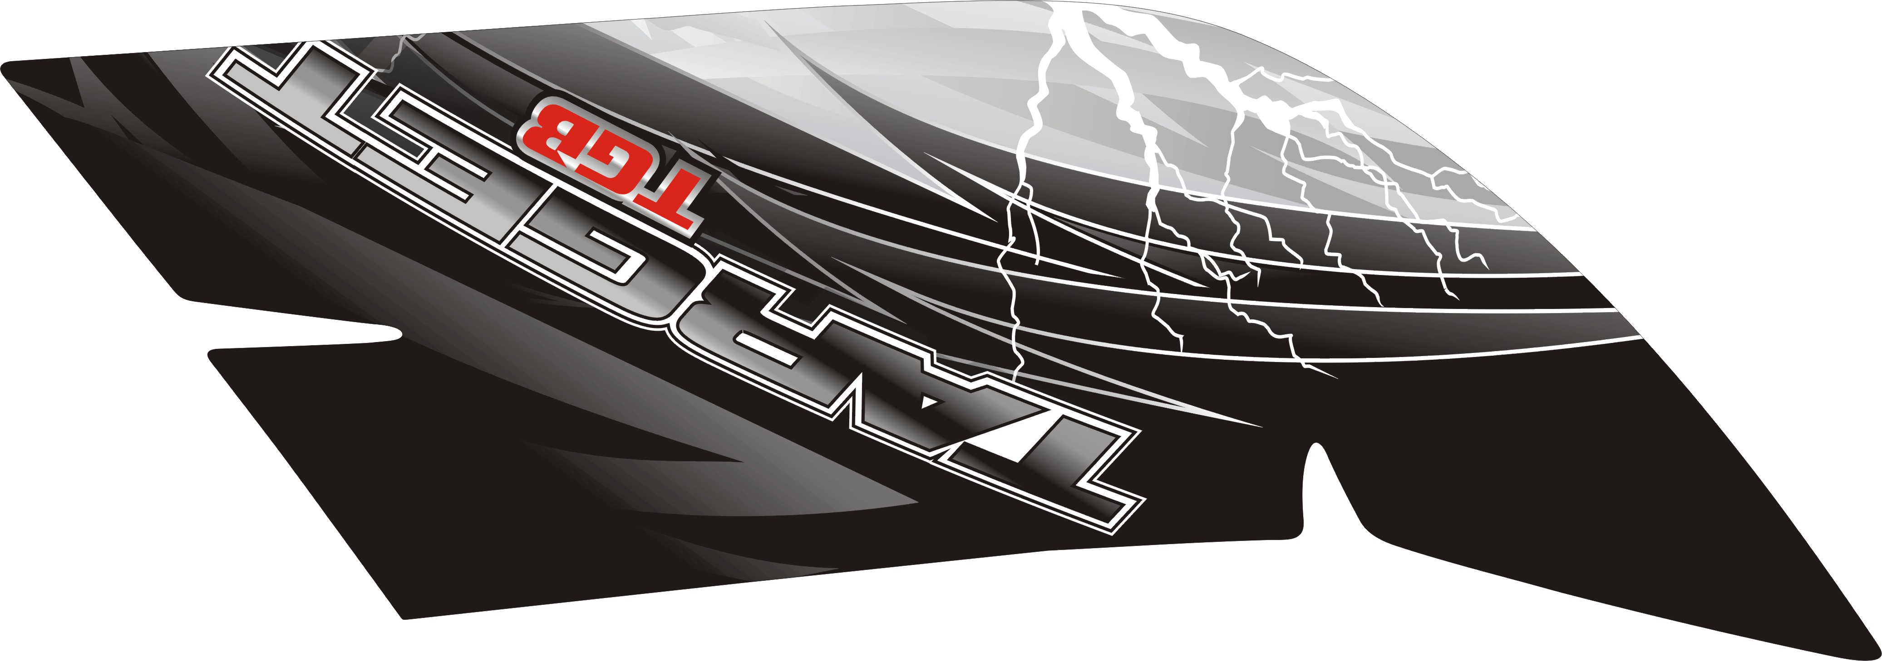 | 516735BL  516735WH | REAR BODY COVER  702,-
 | 516736BL  516736WH | REAR BODY COVER  702,-

VSG-D TABLE OF LABEL
Label | Drawing | Description
 | 516737BL  516737WH | ORNAMENTAL, FRONT COVER  399,-
 | 516738BL  516738WH | COVER SIDE, LH.  399,-

